Communiqué

5 August 2020

The Disability Council NSW held its first virtual forum with peak disability organisations on Wednesday, 5 August 2020. Dr. Ben Gauntlett, Australian Disability Discrimination Commissioner facilitated the session with representatives from 27 organisations participating in the two-hour forum discussing top issues impacting the disability sector. With AUSLAN interpreters from Sweeney Interpreting and live captioning by AI-Media.

Council member, Mr Jake Fing opened the forum with an Acknowledgment to all Aboriginal and Torres Strait Islander countries across Australia with participants calling in from various locations. The Council Chair, Mr Mark Tonga, provided an overview of the forum and introduced the 12 Council members.

Council member, Ms Carolyn Campbell-McLean, briefed the participants on the role of the Council and how it supports the NSW Government by providing independent advice related to people with disability to the Minister for Disability Services, and the importance of building good relationships with peak disability organisations and hearing from people with lived experience.

Dr Rachael Sowden provided an overview of the four strategic priorities of the Council for 2020/21:
- Providing Advice
- Driving improvement in employment
- Progressing a successful National Disability Insurance Scheme (NDIS)
- Influencing the National Agenda

The Chair then welcomed the Disability Discrimination Commissioner, Dr Ben Gauntlett to facilitate the session with peaks.

Some of the key issues and ideas discussed:

Providing Advice:
The impact of emergencies such as COVID-19 and bushfires; the need to ensure people with disability have access to COVID-19 tests; the importance of proactive measures and to have a good plan before any emergency; the importance of viewing disability as the equal of all other diversity characteristics in accessing assistance; the need to have accessible as well as consistent information in a range of formats; advocacy support should be seen as an essential service during a crisis.

While discussing transport, peaks reiterated the need to have accessible transport and the importance of considering of engaging with people with disability at the design stage.

Housing was considered as one of the major issues impacting people with disability. It was widely acknowledged relying on the NDIS or Specialist Disability Accommodation alone wouldn’t solve the issues around accessible and affordable housing for people with disability. It was also acknowledged that universal housing design would benefit all people not just people with disability. There is a need to have universal design as part of the National Construction codes and it is important to have different types of affordable and accessible housing. The forum agreed it was important to provide comment on the recently released Australian Building Codes Board consultation – the proposal to include minimum accessibility standards for housing in the National Construction Code.

Driving improvement in employment:
Peaks appreciated the NSW Government's plan to increase the number of people with disability employed across the NSW public sector to 5.6 per cent by 2025. A number of implementation challenges were identified. For example, old software that can’t integrate screen readers-; understanding the needs of people with disability and adjustments required in terms of assistive technology; the need for people with disability to go through a different recruitment process because of systematic issues - such as jobs requiring psychometric testing.

The forum also looked at the role of education in supporting employment options and the need to have appropriate experience in schools to better support post school options.

All peak organisations agreed that it was critical to ensure that people with disability are able to secure not just jobs, but good jobs, with the opportunity for career progression.

Progressing a successful National Disability Insurance Scheme (NDIS):
Participants discussed that implementing the recommendations suggested by the Tune Review would make a significant difference in improving the quality of NDIS plans. Also discussed was the issue of eligibility of the scheme for people over 65 and the lack of support available via My Aged Care. It was discussed that there is a need to recognise that people over 65 with a significant disability entering aged care, may need supplementary funding.

Influencing the National Agenda:
There was discussion that the NSW Government has to be actively involved as a key stakeholder in the implementation of the National Disability Strategy, and potentially a leader in this area.

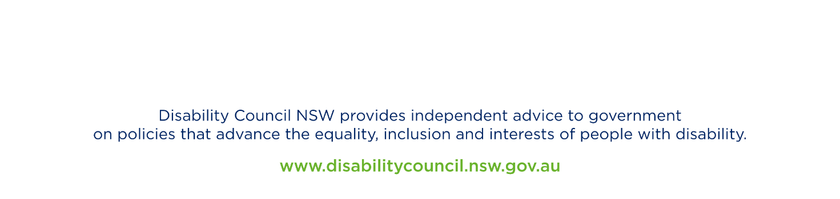
The Chair closed the forum by thanking Dr. Gauntlett and peak organisations for sharing their valuable insights and ideas. The Chair stated that the Council would use information collected to fulfil its advisory function and when responding to important issues impacting people with disability, as well as advising the Government on appropriate program and policy decisions.

Mark Tonga
Chair
Disability Council NSW

#DisabilityCouncilForums

