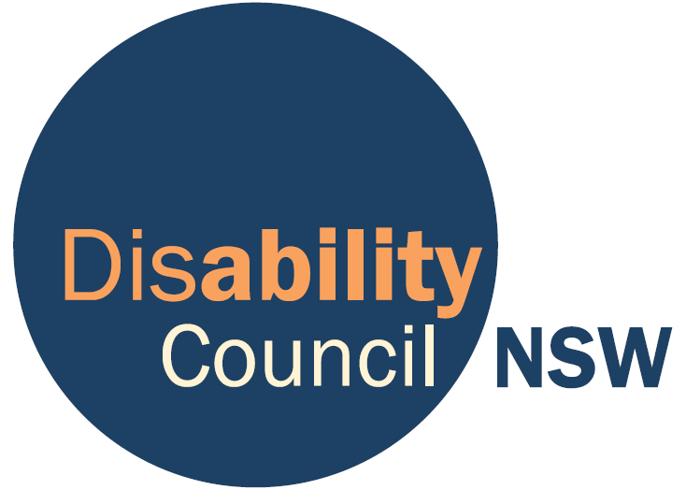

Disability Council NSW
Response to the NSW Disability Inclusion Bill

Develop Capacity
Remove Barriers
Enhance Safeguards
February 2014

Introduction
The Disability Council NSW (Council) is the official advisory body to the NSW Government on issues concerning people with disability. Council currently consists of 11 members with diverse backgrounds, experience and expertise.

Council welcomes the introduction of the Disability Inclusion Bill (the Bill) and appreciates the opportunity to provide the following input to further strengthen this important legal framework. Council was an active contributor during the consultation on the review of the Disability Services Act 1993 (DSA) and is pleased to see that NSW is a step forward in adopting legislation that will more effectively serve the interests of not only people with disability but all people in NSW into the future.

Council strongly supports the philosophy of equal rights and social inclusion which underpins the Bill. Council believes that three essential components are necessary for the real inclusion of people with disability in society to occur:

- people with disability have the capacity to exercise their rights as citizens;
- structural and attitudinal barriers to equal participation are removed; and
- adequate safeguards are in place to protect those in vulnerable situations.

Council’s comments below address these three components.

Develop Capacity
Renaming the Bill ‘Disability Inclusion’ instead of ‘Disability Services’ reflects the fundamental shift in the way people with disability are to be perceived and treated in society. Council strongly supports this timely shift. It signals that people with disability are no longer viewed as passive recipients of services. There is a broadening of their roles in society and the NSW Government is recognising that people with disability are active participants in social, economic and political life.

The Bill focuses mostly on improving mainstream and specialist services for people with disability which is important and necessary. However, Council suggests that it is equally important for the Bill to acknowledge the need to develop the capacity of individuals with disability, regardless of whether they access services or not. This will bring a more balanced approach to ensuring social inclusion.

People with disability experience long-term disadvantage in many aspects of their lives, akin to the long-term disadvantage experienced by the Aboriginal community. Efforts to close the gap include capacity building initiatives to combat disadvantage and foster empowerment, resilience and self-actualisation on an individual level as well as on a community level. The recent establishment by the Government of the Consumer Development Fund is an excellent example of investment in developing the capacity of people with disability to be leaders of their own lives and their communities. Council is keen to see the long-term disadvantage reversed and recommends that people’s right to capacity building supports is included as one of the general principles listed in the Bill.

Council is pleased that the Bill places a legal requirement on government agencies to identify and remove barriers through the disability action planning process. Council believes that people with disability should play a major role in promoting their rights and creating positive social change notwithstanding that support might be needed for their voices to be heard. Council recommends that an additional principle be included acknowledging people’s right to be supported to contribute to social, policy and political debates.

Remove Barriers

Definition of Disability
Council welcomes the rights-based definition of disability, inline with the United Nation’s Convention on the Rights of Persons with Disabilities. This is a major step forward in Australia’s law making and it provides a sound legal basis for the removal of structural barriers that prohibit equal participation.

Principles
Council also welcomes the adoption of principles recognising disadvantaged groups. However, these principles should be observed by all agencies, not just disability service providers. It is a common assumption that people with disability are a homogeneous group and therefore, the needs of people with disability from disadvantaged backgrounds are often overlooked by disability service providers as well as mainstream services. Council believes that the proposed State Disability Inclusion Plan and disability action plans should reflect the full diversity of people with disability and meet the specific needs of people from disadvantaged backgrounds.

Complaints mechanism
The Bill requires agencies to have regard to the principles, yet does not specify a complaints mechanism should a particular agency fail to act in accordance with those principles. Council believes that creating opportunities for citizens to make complaints is a healthy sign of democracy and it encourages continuous improvement. It is recommended that a complaints mechanism be included in the Bill and people with disability be supported to access such a mechanism when necessary.

Disability Action Plans
Council strongly supports the proposed introduction of a State Disability Inclusion Plan and strengthening of the current disability action planning process. The Bill specifies that the plans will follow a four year cycle which is in line with the current Government planning cycle. It is important that disability action planning is fully integrated with Government planning processes and Council would like to see this specified in the Bill so that the intention of integration is clear.

Council would like to see the definition of ‘eligible organisation’ clarified to ensure that all agencies in the government sector, including local councils, develop disability action plans. Under clause 10(3)(b)(iii) Council would like to see ‘accommodating’ replaced with ‘adapting to’, ensuring that the language is consistent with the Social Model of Disability.

An effective Disability Council for an inclusive NSW
Council is pleased to see that its role is strengthened under the Bill with additional functions. In order for Council to fulfil its functions adequately the number of members will need to be increased from the minimum of eight persons and the maximum of 12 persons as proposed in the Bill. These numbers are problematic for two reasons. Firstly, people with disability are extremely diverse with a wide range of impairments as well as age, gender, cultural background, sexual orientation and geographic locations. It will be difficult for a small number of members to adequately reflect the range of views and experience of the disability community and therefore, reduce the breadth and robustness of Council’s advice. Secondly, members generally have to juggle work and family commitments which at times it can be a challenge to meet the demand of attending regular Council meetings as well as working group meetings and external representation requirements. A larger Council will be better able to share Council duties. Council believes that a minimum of 14 and a maximum of 16 is a suitable size for its role.

Council is concerned that the make up of its membership has not been updated to reflect contemporary thinking. All members of the Council should be individuals with disability and/or with expertise in the area of disability. Having departmental officers and employees of disability organisations can create conflicts of interest. Council recommends that clause 15(2)(a) and (b) of the Bill be removed. Instead, Council would like to see the Bill requiring the membership to reflect diversity.

Council believes it is important that the Chairperson of Council is a person with disability and would like to see this included in the Bill as a requirement. Considering its expanded role under the Bill, the Council would also like to see a requirement for a Deputy Chairperson position to be established, to alleviate the demand placed on the Chairperson.

Council welcomes the additional functions although there are still a number of improvements needed. Clause 16(1)(d) should be removed as it is no longer relevant to the current and future landscape. The Council would like to replace the word ‘interests’ with ‘rights’ in clause 16(1)(h) to ensure a consistent rights approach. While Council agrees that it is important to consult with other similar advisory bodies, it is critical that Council consults with people with disability to ensure that the advice is based on their lived experience. Council recommends that clause 16(1)(i) be expanded to include people with disability, their networks and representative organisations.

Council would like to see clause 17 strengthened to specify that there shall be a Secretariat to ensure that Council can exercise its functions properly. In particular, the Secretariat should be resourced appropriately considering Council’s role in monitoring the whole of government in its development and implementation of the disability action plans as proposed by the Bill.

Enhance Safeguards
Council welcomes additional safeguards introduced under the Bill including the requirement to report incidents of abuse to the Ombudsman. It is hoped that the additional scrutiny will bring an improvement to the prevention and handling of abuse in services.

Council recognises the need for a legal mechanism to properly regulate and, more importantly, reduce the use of restrictive practices. Concerns about the use of restrictive practices are not unique to the disability sector. They are also relevant to other areas such as mental health, aged care and juvenile settings. Given the importance of this issue, particularly the potential for abuse of such practices, the Council would prefer restrictive practices to be addressed in other legislation that may be more appropriate than this disability specific Bill.

Part 6 of the Bill brings an improved level of scrutiny by introducing Restricted Practice Authorisation Panels with an independent panel member. However, it is unclear what external mechanism will be available for the review of any concerns that may arise about the operation of the panel and its outcomes.

Clauses 44(2) and (3) of the Bill specify the length and review timeframe of behaviour support plans. Council believes that a 12 month period for review is too long and would like to see plans reviewed at least every three months. This would recognise the serious impact restrictive practices can have on individuals.

Clause 49 requires the use of restraint in an emergency to be reported internally. Council is concerned that this is insufficient in terms of transparency. It is recommended that an independent monitoring mechanism be established to allow the identification of frequent use of restrictive practices by particular services and the development of a more complete picture of such practices across the State with the aim of reducing its prevalence over time.

Clause 50 requires an assessment to be conducted and the possible development of a behaviour support plan. Council would like to see this requirement strengthened by including the development of a behaviour support plan, or a review if one is already in place, and for this review to occur within a prescribed timeframe. This will lessen the risk of prolonged use of restrictive practices in emergency circumstances without appropriate plans.

Conclusion
It has been twenty years since the enactment of the DSA which enshrined the right of people with disability to funded services. Yet many people have very little choice over the support they receive and remain segregated from the wider community. The Bill is a critical opportunity to take a leap forward by enshrining the social, economic and political inclusion of people with disability in State law. Realising such inclusion will present a challenge to us all. However, Council is optimistic that a Bill that develops capacity, removes barriers and enhances safeguards will set us on the path towards an inclusive society.

Summary of Key Recommendations

Council makes the following recommendations:

- That the Bill outline a vision of inclusion based on the following three essential components:
  - people with disability have the capacity to exercise their rights as citizens;
  - structural and attitudinal barriers to equal participation are removed; and
  - adequate safeguards are in place protecting those in vulnerable situations.

- That the Bill include a principle recognising the need to develop the capacity of people with disability to exercise their rights.

- That the Bill include a principle recognising the right of people with disability to be supported to contribute to social, policy and political debates.

- That the clause 5 principles recognising the needs of particular groups should be observed by all agencies, not just disability service providers.

- That the Bill establish a complaint mechanism to hold agencies accountable for adhering to the principles and to enable people with disability to be supported to access such a mechanism when necessary.

- That the Bill specify the need to integrate disability action planning into Government planning processes.

- That the Bill specify the membership of Council at a minimum of 14 and a maximum of 16.

- That clauses 15(2)(a) and (b) be removed and replaced with a requirement for Council membership to reflect the diverse experience of people with disability, as well as their diverse backgrounds including gender, cultural, location and age diversity.

- That the Bill require the Chairperson of the Council to be a person with disability and establish a position of Deputy Chairperson.

- That clause 16(1)(d) should be removed as it is no longer relevant.

- That clause 16(1)(i) be expanded to include people with disability, their networks and representative organisations.

- That clause 17 be strengthened to specify that there shall be a Secretariat that is appropriately resourced to ensure that Council can exercise its functions properly.

- That restrictive practices to be addressed in other legislation that would be more appropriate than this disability specific Bill.

- That the review period of behaviour support plans be reduced from 12 months to three months.

- That an independent monitoring mechanism be established to allow the identification of frequent use of restrictive practices by particular services and the development of a more complete picture of such practices across the State with the aim of reducing its prevalence over time.

- That clause 50 be amended to require the development of a behaviour support plan, or a review if one already exists, within a prescribed timeframe.

Lovelock, H. 2009, Guidelines for interventions that reduce the need for restrictive practices in the disability sector, Australian Psychological Society, Melbourne
Guardianship Tribunal, Position Statement on Management of Challenging Behaviours in People with Dementia,2006

