Restrictive Practices Authorisation in NSW

Consultation findings report

September 2019
Contents
At a glance: what we heard 4
Executive summary 4
About this report 12
Purpose 12
Process 12
Who did we hear from? 14
Perspectives 14
Channels 15
What principles should guide RPA? 17
Recommendations 17
Discussion 18
How should people participate in RPA? 20
Recommendations 20
Discussion 21
Where should RPA be required? 47
Recommendations 47
Discussion 48
Who should make decisions about RPA? 67
Recommendations 67
Discussion 67
Next steps 92
Appendix A – Online survey questions 93
Appendix B – Responding organisations 96
Appendix C – List of facilitated forums 97
Appendix D – List of acronyms 98

At a glance: what we heard

Executive summary
This report summarises the key themes and findings from a public consultation process conducted by the NSW Government from 16 July 2019 to 30 August 2019 on the topic of Restrictive Practices Authorisation (RPA). The purpose of this public consultation was to inform development of an ongoing model for regulating RPA in NSW.
We consulted with persons with disability, families, carers, service providers, organisations, and other interested people through multiple channels, based around a Have Your Say webpage. Channels for consultation included:
- an online survey
- face-to-face forums
- online webinars
- a telephone submission line
- email and mail for written submissions.
A NSW Government RPA Consultation Discussion Paper (Consultation Discussion Paper) was released to inform and guide contributions to the consultation process, based on the same four overarching questions that provide the structure for this report:
- What principles should guide the authorisation of restrictive practices?
- How should people participate in the authorisation of restrictive practices?
- Where should restrictive practices authorisation be required?
- Who should make decisions about authorising restrictive practices?
The consultation process sought responses from three key perspectives:
- Persons with disability (120 responses)
- Other interested persons, such as family members of a person with disability (57 responses)
- Service providers (155 responses).
We also received formal submissions from 16 organisations.
Most respondents, from all perspectives, had direct experience with the use of restrictive practices or the RPA process. Some of the people who contributed to this review had traumatic experiences with restrictive practices. Some of these were authorised restrictive practices used in regulated settings, while others were unauthorised and/or unregulated.

What principles should guide the authorisation of restrictive practices?
The Consultation Discussion Paper proposed six principles for RPA in NSW:
- Person centred
- Least restrictive
- For the shortest time
- Helping to reduce and eliminate restrictive practices
- Monitored
- Reviewed regularly.
Respondents indicated high levels of support for each of these six principles. ‘Person centred’ was the principle most frequently supported by respondents, particularly among persons with disability and other interested persons.
Recommendation: Adopt the six principles proposed in the discussion paper.

How should people participate in the authorisation of restrictive practices?
Respondents said that persons with disability should be clearly informed about restrictive practices and RPA. Service providers tended to say that persons with disability should participate by attending RPA Panel meetings, being consulted on Behaviour Support Plans (BSPs), being consulted on decisions, and participating via a guardian or champion. The most widely held view by other interested persons was that persons with disability should participate to the limits of their capacity, rather than via a guardian or champion. In contrast with these perspectives, persons with disability were more likely to want to be consulted on decisions via guardians or champions, or directly. While some persons with disability said that they wanted to attend RPA Panels, this was not a strong theme.
Recommendation: Encourage participation in RPA decisions beyond RPA Panel meetings.
Respondents emphasised the value of supporting persons with disability to be directly involved in RPA decisions, including with easy information and interpreter or communications support if the person needs or wants this. More persons with disability expressed a preference for support from independent champions rather than families or guardians, and for capacity building around decision making.
Respondents said that direct participation by persons with disability in RPA decisions is rare; however, a substantial proportion of respondents had experienced this at least once. Service providers were more likely to say that direct participation by persons with disability in RPA decisions was a good experience, although a substantial number also reported bad experiences of persons with disability participating in RPA decisions. Most other interested persons also said that their experience of directly participating in RPA decisions was good. Persons with disability, however, overwhelmingly said that their experience was bad, usually because they did not feel heard, or found the process emotionally difficult.
Recommendation: Make changes to improve the experience of RPA for persons with disability.
There was strong support for families and carers to be consulted on, and involved in, decisions about RPA because of their close relationships with, and care and concern for the interests of, persons with disability. Some respondents, particularly persons with disability, said that persons with disability should be able to limit the authority of families and carers in this role. There was a strong desire for families and carers to have access to capacity building, information and resources about RPA decisions. Some service providers were concerned about the workload to provide this support and wanted appropriate general guidance and resources to be made available for families and carers.
Recommendation: Increase availability of information about RPA for families and carers.
There was strong support for consent to remain a mandatory part of RPA in NSW and for persons with disability to consent directly where they have the capacity to do so. Guardians were accepted as substitute decision-makers by most respondents where the person with disability does not have the capacity to decide for themselves. Many service providers raised operational challenges associated with administering consent, particularly when working with institutional decision makers.
Recommendation: Continue to require consent as a condition for RPA in NSW.
There was a strong desire for more capability building and easy information around consent for RPA. Service providers wanted clearer guidelines and frameworks, as well as roles and responsibilities for obtaining consent. Persons with disability wanted support from independent champions and, to a lesser degree, guardians and families, as well as support to communicate their wishes. Persons with disability also wanted to have enough time to consider information before needing to make decisions about consent.
Recommendation: Increase availability of information about consent for RPA.
Recommendation: Liaise with the NDIA to improve access to communication support and capacity building around decision making.
More persons with disability and other interested persons who said they were involved in consent found this to be a good experience than found participating in RPA decisions generally to be a good experience. This was not the case for service providers, who reported good and bad experiences around consent in roughly equal numbers. People with good experiences tended to emphasise the opportunity to be heard and to access expert advice. Service providers who had bad experiences tended to emphasise the slowness of the process, risks around withholding or withdrawal of consent, and challenges engaging with institutional decision makers. Persons with disability and other interested persons who had bad experiences tended to report feeling disempowered, or not heard. Some of the persons with disability who said they had consented to the use of a restrictive practice did not feel that their consent had been informed or voluntary.
Recommendation: Clarify that consent must be informed and voluntary and link this requirement to the RPA principles in explanatory text.

Where should restrictive practices authorisation be required?
The Consultation Discussion Paper introduced the idea that persons with disability may need behaviour support in many different settings or places, like home, work, school, hospitals, outside, and when receiving services from National Disability Insurance Scheme (NDIS) providers. Restrictive practices could be used in any of these settings, but only some settings need authorisation under the interim NSW RPA Policy.
There was strong support, from all perspectives, to expand the scope of RPA regulation in NSW beyond NDIS providers delivering services to an NDIS participant. Most respondents said that restrictive practices should be authorised before they can be used in all settings.
Recommendation: Expand the scope of settings where RPA is required.
Most respondents said they wanted principles to be harmonised across all settings where restrictive practices are, or could be, used to support persons with disability. Some respondents said that harmonising principles is a less intrusive and disruptive way of improving consistency and safeguarding, without adopting the same RPA process across settings. Service providers and other interested persons had an appetite to adopt consistent RPA processes across more settings, but more persons with disability wanted consistent processes only in institutional/professional service settings, including health and mental health services, and justice settings.
Recommendation: Harmonise RPA principles across institutional/professional settings.
Most respondents said that they have experienced restrictive practices being used or authorised for a person with disability across more than one setting and that this does not work well under the current system. The most common problems cited were inconsistent approaches, poor communication, and limited collaboration.
Despite raising concerns about inconsistencies and poor communication across settings, many respondents, particularly among persons with disability, said they did not want a single authorisation to apply across settings. Some persons with disability said that more targeted plans would better meet their needs, or were concerned that a single authorisation could increase the risks associated with a bad decision. Service providers raised a number of concerns about how authorisation across settings would work in practice, particularly with regard to resource constraints and operational challenges. Many respondents, however, thought that authorisation across settings would improve collaboration and outcomes for persons with disability.

Recommendation: Liaise with the Australian Government to encourage collaboration around behaviour support.
There was a strong desire to improve consistency of RPA around a rights-based framework. The need for capacity building, a common regulatory framework, and information sharing/collaboration were strong themes across all three perspectives. Fewer service providers emphasised capacity building than did persons with disability, for whom this was the strongest theme.
Recommendation: Facilitate, but do not require, authorisation across settings.

Who should make decisions about authorising restrictive practices?
There was an important difference between the perspectives of persons with disability and service providers in relation to who should make decisions about authorising restrictive practices. Service providers tended to emphasise the importance of expert opinions, professional participants, and good governance considerations. Persons with disability tended to emphasise a desire to trust and be known by people who make, or help them to make, decisions about their lives.

I don’t want someone that I don’t know and don’t trust to support me
Person with Disability

There was strong support among respondents for NSW to continue to operate a model based primarily on local panels, convened by service providers, making decisions about RPA. This included many respondents who wanted a mix of central and local panels to make different types of decisions under different circumstances. In a mixed model, central panels were variously proposed to handle more complex cases, authorisations across settings, specialist or highly technical cases, and appeals or reviews.
Recommendation: Continue to empower local panels to make RPA decisions.
Most respondents indicated that decision makers should have behaviour support and clinical skills and experience. This suggests that most respondents think about RPA as a safeguarding approach more in line with clinical governance than with more legalistic frameworks, although some respondents did identify legal/human rights skills as being relevant. Many service providers felt that knowledge of the person/setting and operational understanding were important skills and experience for decision makers. Persons with disability felt that cultural competency, legal/human rights skills, and lived experience were important.
More persons with disability put high value on experiential support for decision makers to know and understand the person, e.g. advice from persons with disability, and knowledge of the person. Other respondents put high value on technical support for decision makers, e.g. expert advice, ongoing training, and examples/case studies.
Recommendation: Continue to require current minimum skills and experience for RPA Panel members.
Service providers and other interested persons reinforced the current conditions for use of a restrictive practice to be authorised: a BSP based on a functional behavioural assessment; informed consent; and authorisation by an RPA Panel. Some persons with disability wanted to add a requirement for evidence of current risk due to behaviours of concern and less restrictive alternatives tried as conditions for authorisation.
Recommendation: Continue to require current conditions for RPA.
There was overwhelming support for the introduction of a formal process for appealing RPA decisions in NSW. Persons with disability said that they wanted decisions to be reviewed both as requested, and on a regular schedule.
Recommendation: Introduce a formal process to appeal RPA decisions in NSW.
Recommendation: Empower persons with disability, or their guardians, to appeal for a formal review of an RPA decision.
There was a consistent preference for independent central panels and independent experts to consider reviews or appeals. Many persons with disability, however, talked about including new decision makers, but not necessarily through a central panel. Some service providers raised concerns about workload implications of a review process and made suggestions to ensure that effort invested in appeals is well targeted.
Recommendation: Establish independent central panels to consider appeals.
Most respondents, particularly service providers, wanted external oversight of processes and decisions. This included process reviews and external auditing, as well as routine oversight, e.g. by Independent Specialists who are funded by the NSW Department of Communities and Justice (DCJ) to participate in RPA Panels.
Recommendation: Maintain current monitoring mechanisms.
Recommendation: Liaise with the Australian Government to align enforcement powers.
Respondents indicated a desire for a capacity building and supportive approach to improving RPA decision making, with the potential for an RPA Panel or RPA Panel member to be deregistered or suspended. Many service providers wanted to align or combine enforcement powers with those of the NDIS Quality and Safeguards Commission.
Respondents preferred a regulatory approach that combines a platform of legislation to define principles and enforcement powers with a policy framework that enables flexibility. Flexibility was seen to be desirable to accommodate local variation, and scope for adjustment as the full-scheme NDIS matures, capability increases among decision makers, and more settings harmonise principles and work through implementation considerations.
Recommendation: Consider light touch legislation, supported by a NSW strategy and/or policy framework.

About this report

Purpose
This report summarises the key themes and findings from a public consultation process conducted by the NSW Government from 16 July 2019 to 30 August 2019 on the topic of Restrictive Practices Authorisation. The purpose of this public consultation was to inform development of an ongoing model for regulating RPA in NSW.
NSW currently has an interim approach to authorising restrictive practices, which started on 1 July 2018 with the full-scheme NDIS. The interim approach will end on 30 June 2020. The NSW Government needs to design the way we will authorise restrictive practices from 1 July 2020.
The consultation process focused only on how the use of restrictive practices should be authorised in NSW. Broader questions about behaviour support, which is regulated by the Australian Government, were not part of this consultation.

Process
We consulted with persons with disability, families, carers, service providers, organisations, and other interested people through multiple channels, based around a Have Your Say webpage. Channels for consultation included:
- an online survey
- face-to-face forums
- online webinars
- a telephone submission line
- email and mail for written submissions.
A NSW Government RPA Consultation Discussion Paper was released to inform and guide contributions to the consultation process, based on four overarching questions:
- What principles should guide the authorisation of restrictive practices?
- How should people participate in the authorisation of restrictive practices?
- Where should restrictive practices authorisation be required?
- Who should make decisions about authorising restrictive practices?
Each of these overarching questions included more detailed questions exploring that topic. These questions are listed at Appendix A.
Analytics from the Have Your Say webpage are included at Appendix B.

Who did we hear from?
All contributors to this consultation were given an opportunity to request that their responses be kept confidential and advised that all submissions would otherwise be treated as public and anonymous. Contributions made confidentially were coded and analysed, and are included in summary charts below; however, no quotations from confidential contributions are included this report.
Figure 1 - Who did we hear from
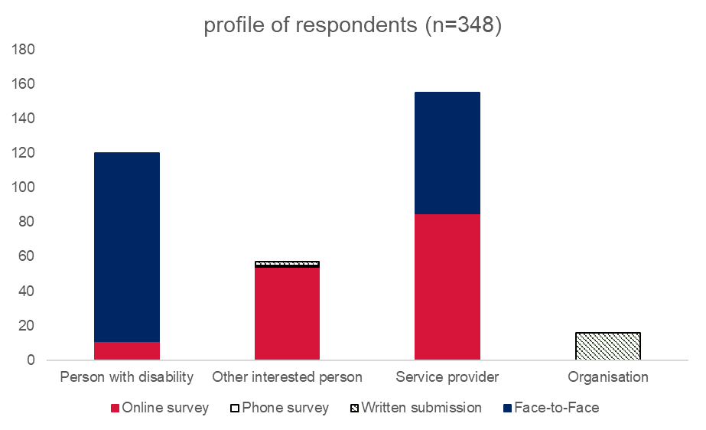
We received 348 responses from contributors across all channels, summarised in figure 1.

Perspectives
The NSW Government RPA Consultation Discussion Paper and the consultation process sought responses from three key perspectives:
- Persons with disability (120 responses)
- Other interested persons, such as family members of a person with disability (57 responses)
- Service providers (155 responses).
We also received formal submissions from 15 organisations, listed at Appendix C.
Slightly different questions were presented to contributors from each of the different perspectives. A full list of questions for all three perspectives is at Appendix A.
For the online and phone survey, participants were asked to identify the perspective that best applied to them and were only presented with the questions relevant to their chosen perspective. Face-to-face forums were targeted at either persons with disability, or service providers, and participants were presented with the relevant questions for that perspective.
Some of the face-to-face forums for persons with disability included additional attendees, mostly support people such as family members, peer support workers, support staff, or other community members. Responses from these 24 other interested persons and three service providers have been coded based on the primary perspective of the forums they attended. Some face-to-face forums attended mostly by service providers also included additional attendees whose responses have been coded based on the perspective of the forum. This included three persons with disability and eight other interested persons. Where a position or consensus view was expressed in one of these forums, all contributors to that forum have been included in the count of people who expressed that view, except where the facilitator clearly indicated who did or did not express that view.
The actual counts of contributors from each perspective, adjusted for these cases, was:
- Persons with disability (96)
- Other interested persons (89)
- Service providers (147).

Channels
The online survey received 150 submissions, including 11 persons with disability, 54 other interested persons, and 85 service providers. The survey was hosted on the SurveyMonkey platform. The first question, identifying the perspective from which the person was responding, was mandatory. All other questions were optional.
Seventeen forums, 15 face-to-face and two webinars, were conducted as part of the consultation process. This included 12 forums primarily for persons with disability and five forums primarily with service providers. The forums were facilitated by organisations with expertise and experience in engaging and consulting with the groups of people attending each forum. A total of 179 responses were submitted through forums, including 109 from persons with disability and 70 from service providers. A list of the forums and facilitating organisations is at Appendix D. RPA consultation conversation guides were supplied to help facilitators guide the forums.
A phone survey was made available, hosted by WayAhead, using the same questions as the online survey. Respondents calling a 1300-number could be guided through the questions. WayAhead received one response from an other interested person, and one other call requesting assistance with responding to the discussion questions.
Eighteen written submissions were received by email, including 16 from organisations and two from other interested persons. No submissions were received by mail.

What principles should guide RPA?
The Consultation Discussion Paper introduced the idea that clear principles can help people to understand things like:
- Why restrictive practices must not be used unless they have been authorised
- When restrictive practices should be authorised
- How authorisation should be managed.
The Consultation Discussion Paper also introduced, and briefly explained, six principles:
- Person centred
- Least restrictive
- For the shortest time
- Helping to reduce and eliminate restrictive practices
- Monitored
- Reviewed regularly.

Recommendations
- Adopt the six principles proposed in the discussion paper.

Discussion

Q1: What principles should guide RPA in NSW?
Figure 2 - Q1: What principles should guide RPA in NSW?
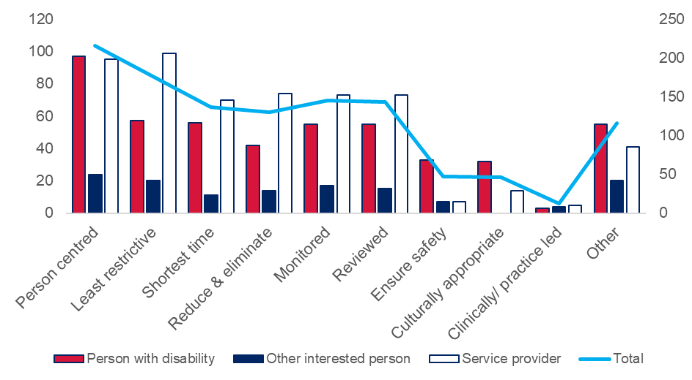
Respondents indicated high levels of support for each of the six principles proposed in the Consultation Discussion Paper. ‘Person centred’ was the principle most frequently stated by respondents, particularly among persons with disability and other interested persons.

The Principles described in the consultation paper as a parent I can appreciate, and they would give me reassurance if they ensured my young person’s rights, well-being and safety.
- Other Interested Person

Some respondents suggested additional or alternative principles. Among these, the most common were:
- Ensure safety
- Culturally appropriate.

Only ever to be used to ensure immediate safety of the individual or those in close proximity.
- Person with Disability

It needs to be more inclusive of cultural practice and place in country, particularly those who live rural and remote.
- Person with Disability

A concern was raised in one face-to-face forum for persons with disability that the language of these principles is not easy to read and understand. This concern was not widely expressed by respondents, but we note it here because of its relevance.

The guiding principles are “hard to understand.” The language should be easy to read and understand. If restrictive practices authorisations are about the person with a disability, then the person with a disability should be able to understand them. When the guiding principles were explained people thought that they were all important.
- Persons with Disability

How should people participate in RPA?
The Consultation Discussion Paper explored three broad themes in this section:
- How should people with disability participate in RPA?
- How should families and carers participate in RPA?
- How should consent be part of RPA?
Questions for each of these themes explored the experience of the respondent, their views on how people should participate in RPA decisions, and what support people need to participate in RPA decisions. Some of these questions were different depending on the perspective of the respondent, e.g. person with disability or other interested person.

Recommendations
- Encourage participation in RPA decisions beyond RPA Panel meetings.
- Make changes to improve the experience of RPA for persons with disability.
- Increase availability of information about RPA for families and carers.
- Continue to require consent as a condition for RPA in NSW.
- Increase availability of information about consent for RPA.
- Liaise with the NDIA to improve access to communication support and capacity building around decision making.
- Clarify that consent must be informed and voluntary and link this requirement to the RPA principles in explanatory text.

Discussion

Q2a: Has a restrictive practice been used as part of your supports; or have you participated in the authorisation of a restrictive practice?
Most respondents, from all perspectives, had direct experience with the use of restrictive practices or the RPA process.
Figure 3 - Q2a: Has a restrictive practice been used as part of your supports; or have you participated in the authorisation of a restrictive practice?
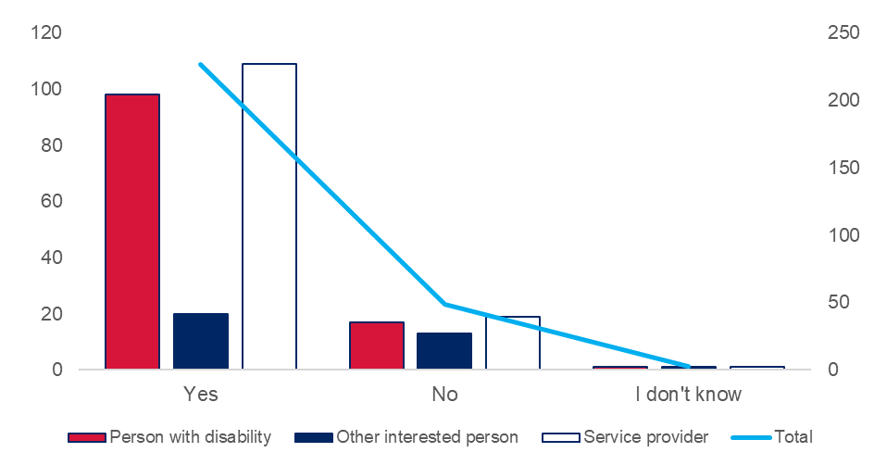
Although most respondents had experience of RPA in disability support settings, we also heard about experiences of restrictive practices in other settings, including mental health, education, justice, out-of-home care, and family homes.

Two (persons with disability) has personally had a restrictive practice used as part of their care that had been authorised via the Mental Health Act as an involuntary admission to hospital. Neither had participated in the authorisation process.
- Persons with Disability

Q2b: If yes, how did you participate in the authorisation process; or how did the person with disability participate (for Service Providers)?
Figure 4 - Q2b: If yes, how did you participate in the authorisation process; or how did the person with disability participate (for Service Providers)?
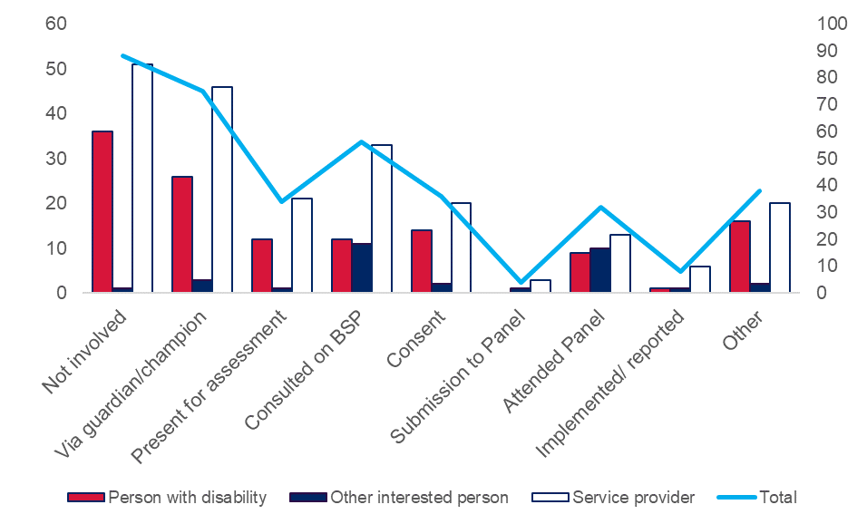
Respondents from all perspectives told us that it is rare for persons with disability to be directly involved in RPA decisions. Some persons with disability are represented by guardians or family members.

Very infrequently that people with disabilities are involved – more often families.
- Service Provider

We also heard that families and guardians are not always actively engaged in RPA decision making beyond signing documents.

A staff member provided the client information and got the BIS plan signed by the parent/Guardian. There was no information that the person had been involved in any way. I participate in panels monthly and it is the same pattern.
- Service Provider

Q2c: If yes, in what ways was the experience good or bad?
Although direct participation by persons with disability in RPA decisions is rare, a substantial proportion of respondents had experienced this at least once.
Figure 5 - Q2c: If yes, in what ways was the experience good or bad?
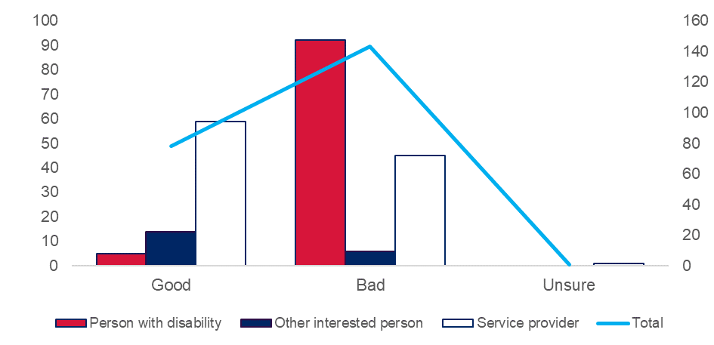
Most other interested persons who responded to this question reported that the experience of directly participating in RPA decisions was good. In most cases these responses referred to the other interested person’s own participation and experience, rather than that of the person with disability.

Good – I feel that I have control over what is in the best interests of my son.
- Other Interested Person

Service providers were also more likely to report that direct participation by persons with disability in RPA decisions was a good experience, although a substantial number also reported bad experiences of persons with disability participating in RPA decisions.

It was great, the person was highly vocal about their experience and views. They remained in charge of their supports and could see the options tested to reaching the point of the RP being required.
- Service Provider

Persons with disability, however, overwhelmingly reported that their experience was bad.
I didn’t have my opinion heard or choices.
- Person with Disability
Figure 6 - Q2c: If yes, in what ways was the experience good or bad?
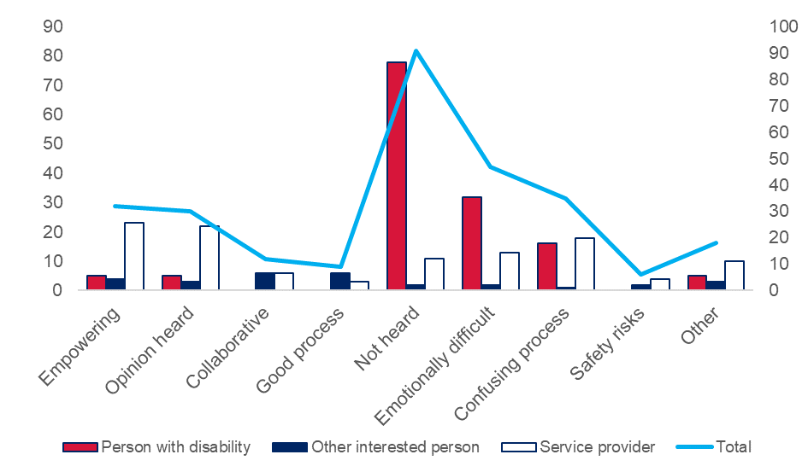
The most common themes where the experience was good were around empowerment of the person with disability and feeling heard. These themes were reported from all perspectives, including the small number of persons with disability who reported positive experiences engaging with the RPA process.

It was good that they asked me and involved me. I got to saw what I wanted to happen.
- Person with Disability

It was very empowering for this individual and also supported the panel to understand the nuances of the person’s disability. It was also part of a larger process of supporting the individual to understand their own disability and be able to express this to others.
- Service Provider

Even among respondents who described some positive experiences, many acknowledged that direct participation in RPA decisions can also be stressful and difficult for persons with disability.
When customers attend, they have the opportunity to share their story and again, this can be a positive experience for the customer or it can be negative, bringing up past experiences which the customer finds distressing and which impacts on the customer for days.
- Service Provider
Some persons with disability also acknowledged this tension between the desire to be heard, and the stress of participating in the process.

I was anxious about attending the panel and not feeling good about not having any power. I wanted to have my say.
- Person with Disability
Where people reported that their experience was bad, the most common themes were around the person with disability not feeling heard or finding the process emotionally difficult. Some respondents also found the process confusing or alienating.
Some persons with disability who reported not feeling heard felt that they had been entirely excluded from the decision-making process. Others reported that their opportunities for participation were meaningless.

They just tell me to sign the form, so I sign it. They don’t read it to me or anything.
- Person with Disability

Some persons with disability reported that the nature of their disability or illness contributed to the experience being bad and confusing.

It can be very bad when you are not well and not able to understand what you have previously discussed.
- Person with Disability

Q3: How should people with disability participate in RPA decisions?
Figure 7 Q3: How should people with disability participate in RPA decisions?
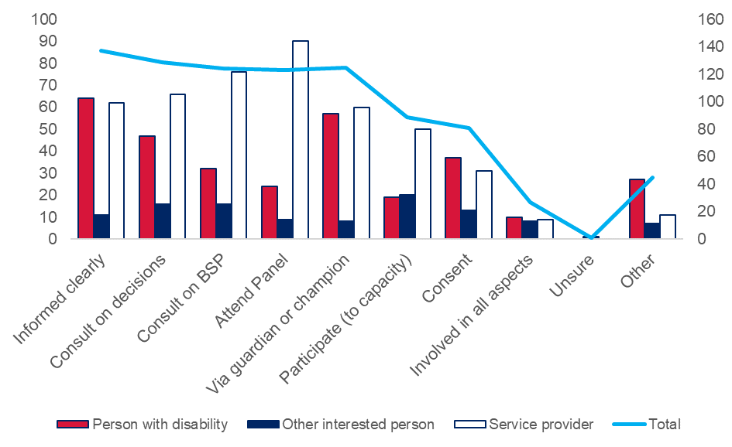
Respondents from all perspectives said that persons with disability should be clearly informed about restrictive practices and RPA.

If I have all the information I can understand. But people don’t tell me everything. And then I don’t understand.
- Person with Disability

Service providers tended to say that persons with disability should participate by attending RPA Panel meetings, being consulted on BSPs, being consulted on decisions, and participating via a guardian or champion.

Where possible, being consulted about their BSP, and being able to tell the people on the RPA Panel what they think.
- Service Provider

The strongest single theme for other interested persons was that the person with disability be able to participate to the limits of their capacity. Representation via a guardian or champion was the weakest theme in the responses of other interested persons to this question.

Be central to process and participate in all aspects of process, not just have another person such as a guardian participate and make decisions on their behalf.
- Other Interested Person

In contrast with both of these perspectives, persons with disability were more likely to want to be consulted on decisions via guardians or champions, or directly. While some persons with disability said that they want to attend RPA Panels, this was not a strong theme for respondents from this perspective.

We need to have an individual advocate to support our needs and understand our disability and the RPA process.
- Person with Disability

While not a strong theme for any one perspective, consent was raised by a substantial proportion of respondents from all three perspectives as a way that persons with disability should participate in RPA decisions.

No form of restraint or seclusion or restrictive practice should ever be carried out without the prior written consent of a disabled person or their representative.
- Person with Disability

Q4: How should people with disability be supported to participate in RPA decisions?
Figure 8 - Q4: How should people with disability be supported to participate in RPA decisions?
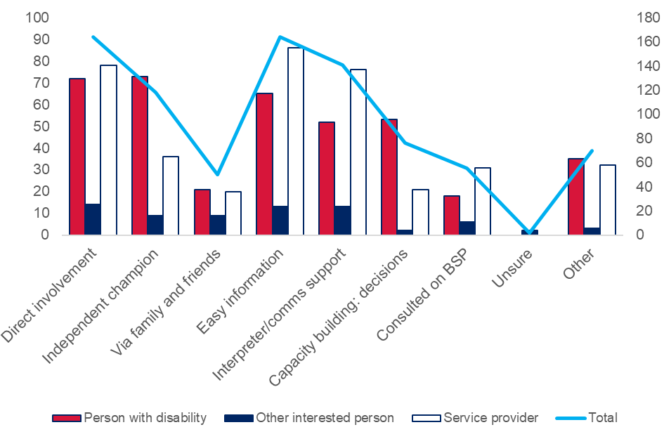
Respondents from all three perspectives emphasised the value of supporting persons with disability to be directly involved in RPA decisions, including with easy information and interpreter or communications support if the person needs or wants this.

Communication support, both expressive and receptive. A speech pathologist should be involved to help communicate choices/decisions so that a person with disability has the best chance of understanding.
- Other Interested Person

More persons with disability than respondents from either of the other two perspectives expressed a preference for support from independent champions, and for capacity building around decision making. Many more persons with disability expressed a desire for support from independent champions than from family members and friends.

They (persons with disability) need to be educated about the processes and the information should be in easy read format, we can learn if our capacity building is supported and we can tell others.
- Person with Disability

Have an individual advocate for them and at all meetings with the RPA panel, resources developed in easy English and be the first to speak.
- Person with Disability

Q5: How should families and carers participate in RPA?
Figure 9 - Q5: How should families and carers participate in RPA?
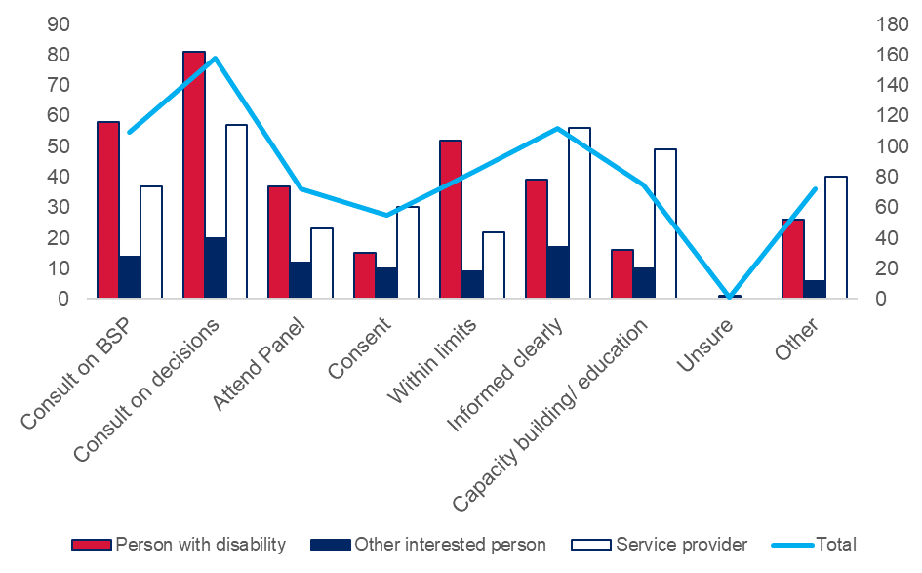
There was strong support for families and carers being consulted on, and involved in, decisions about RPA because of their close relationships with, and care and concern for the interests of, persons with disability.

Family is important and they can have a voice about what they think is right.
- Person with Disability

Some respondents wanted this involvement to be mandatory, particularly for children and young people.

Families are often the main caregivers of children and young people with disability and therefore they must be involved in the development of Behaviour Support Plans and this must not be optional.
- Person with Disability

Some respondents, particularly persons with disability, said that persons with disability should be able to limit the authority of families and carers in this role. In some cases, this was driven by concern about family members who might not have a close relationship with a person with disability but may still have a lot of influence in the person’s life.

It should be the choice of the person with a disability if they want their family members or carers to participate. If you do not see much of your family and carers you might not want them to be involved.
- Person with Disability

Unless the person with disability does not wish it to happen, families and carers should be present and allowed to listen, ask questions and communicate in all meetings.
- Other Interested Person

Some respondents were concerned that family members and carers could be pressured or coerced by service providers into compromising the rights of persons with disability, e.g. with the threat of services being withdrawn from the person.

Carers and families should never under any circumstances be coerced into accepting less than best practice or compromising the rights of their disabled family members! It is never acceptable to make inclusion conditional on total compliance or make non-compliance or refusal punishable by exclusion or restraint!
– Person with Disability

Families/carers need to be supported to provide truthful input, to prevent pressure being applied for the benefit of the service provider.
– Service Provider

Some service providers also expressed concern about situations in which family members or carers wanted unnecessarily restrictive practices to be used in the supports of a person with disability. Many of these respondents said there should be capacity building for families and carers as part of the behaviour support planning and RPA processes to help improve understanding about how to reduce and eliminate the use of restrictive practices.

Families and carers require every opportunity to learn behaviour strategies prior to moving on to RP. Be given opportunities to try other strategies prior to moving on to the RP. Once they have tried all options parents/carers need the opportunity to discuss their concerns and how the safety of the child impacts on them and then be part of drawing up the behaviour support plan.
– Service Provider

The focus on reducing and eliminating RP use is a shared responsibility – this includes families and health care providers including medication prescribers.
– Service Provider

Q6: How should families and carers be supported to participate in RPA decisions?
Figure 10 - Q6: How should families and carers be supported to participate in RPA decisions?
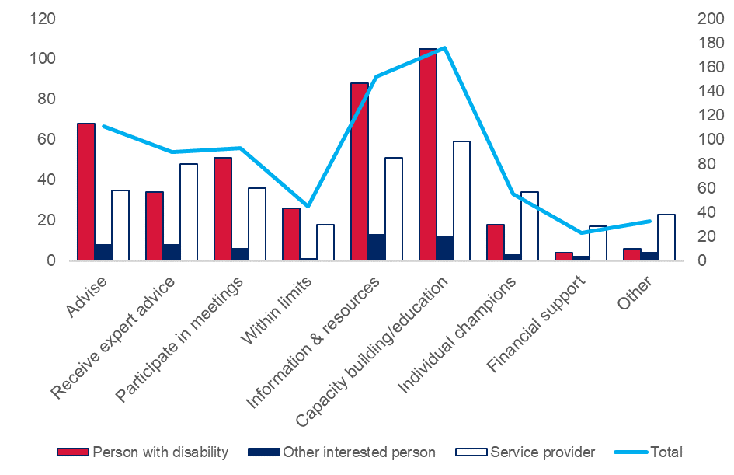
There was a strong desire, across all perspectives, for families and carers to have access to capacity building, information and resources about RPA decisions.

Education on what RPA is and the process.
– Other Interested Person

There needs to be a lot of resources, not just readable, but videos and the why's. Case studies, etc.
– Service Provider

Service providers said that there should be more capacity building for families and carers but were concerned about the workload to provide this support. They wanted appropriate general guidance and resources to be made available for families and carers.

Need clearer guidelines for education process re: info for families – not left up to individual providers to decipher or interpret.
- Service Provider

Some respondents expressed a concern that support and encouragement to participate in RPA decisions should not be interpreted as a mandatory obligation on families and carers that they might find emotionally or practically difficult.

Should be encouragement for attending panels, but ultimately their choice.
- Service Provider

Persons with disability wanted families and carers to be actively supported to advise on RPA decisions, based on their close knowledge and experience of the person with disability. Persons with disability also wanted families and carers to be supported to participate in meetings without feeling pressured to accept unnecessarily restrictive practices.

They should have access to advocates who understand the disabilities their kids have so they have support if they're feeling pressured to accept restrictions and like they have people on their team to help stand up against a school or support worker or whatever.
– Person with Disability

Q7a: Have you been involved in consent for a restrictive practice?
Figure 11 - Q7a: Have you been involved in consent for a restrictive practice?
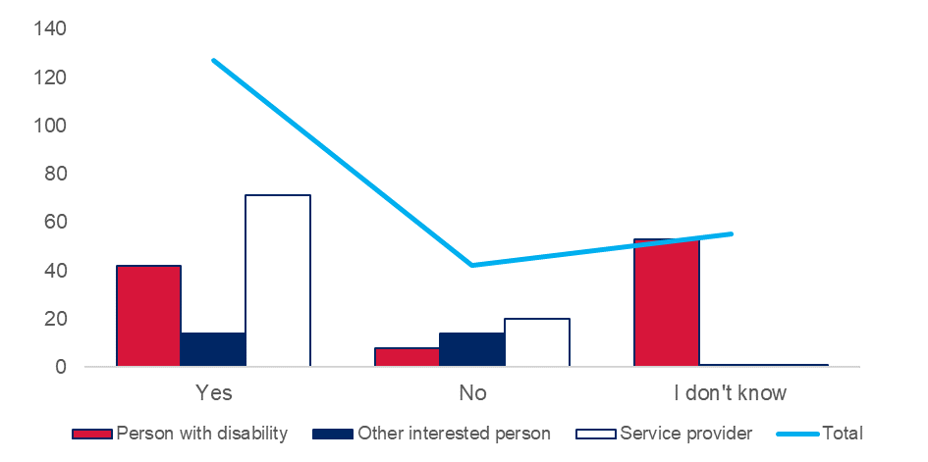
Most respondents had direct experience of consent for the use of a restrictive practice. This is despite relatively small numbers of persons with disability and other interested persons among respondents reporting being involved in giving consent.

No consent has been given by me, it’s with my guardian.
- Person with Disability

Q7b: If yes, how were you involved?
Figure 12 - Q7b: If yes, how were you involved?
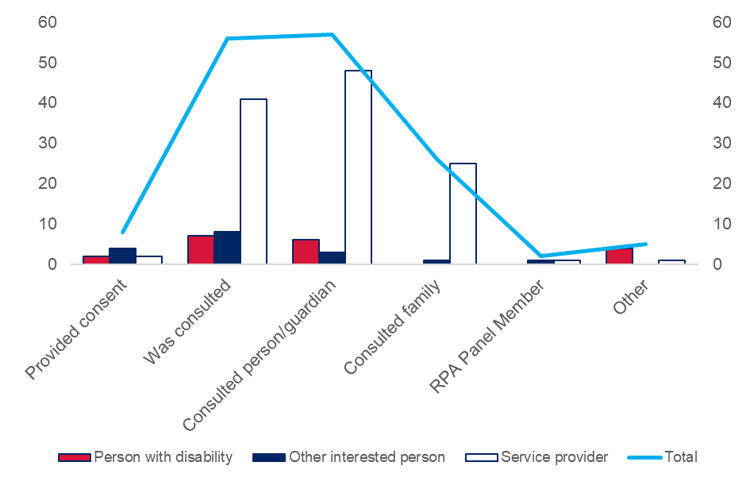
Some responses from service providers suggested explanations for the relatively low proportion of persons with disability and other interested persons among respondents who indicated that they have been involved in consent.

Often done as an afterthought and asking consent givers who don’t understand as well to sign something - rather than informed consent.
– Service Provider

Historically, the majority of clients have not really been given the opportunity to participate in RPA. The clients we support have complex needs and consent has been obtained from Guardians etc. Information from clinicians and people who work with the clients is relied heavily upon.
– Service Provider

Some of the persons with disability who did report having consented to the use of a restrictive practice did not feel that their consent had been informed or voluntary.
Participant had ‘legally’ consented to be given medication by signing a form, however this was not explained to her and she did not understand the consequence. Consent felt like ‘ticking a box’ as opposed to being a process of understanding for the PWD. Feeling influenced by power imbalance of clinical setting.
– Persons with Disability

Service providers tended to report being involved in consulting others about consent, although some said they had been consulted to answer questions from persons with disability or guardians, or to assess the capacity of a person with disability to consent.

Speaking to families and carers around the need for the RP. Ensuring they have a full understanding of the RP and why there is a need. Answering questions, providing evidence (incident reports, data collection etc). Communicating with the Office of the Public Guardian - also providing evidence of need etc.
– Service Provider

Some service providers said that obtaining informed consent from a person with disability or guardian can be a lot of work.

Working with the person on consent and required several sessions.
- Other Interested Person

Q7c: If yes, in what ways was the experience good or bad?
Figure 13 - Q7c: If yes, in what ways was the experience good or bad?
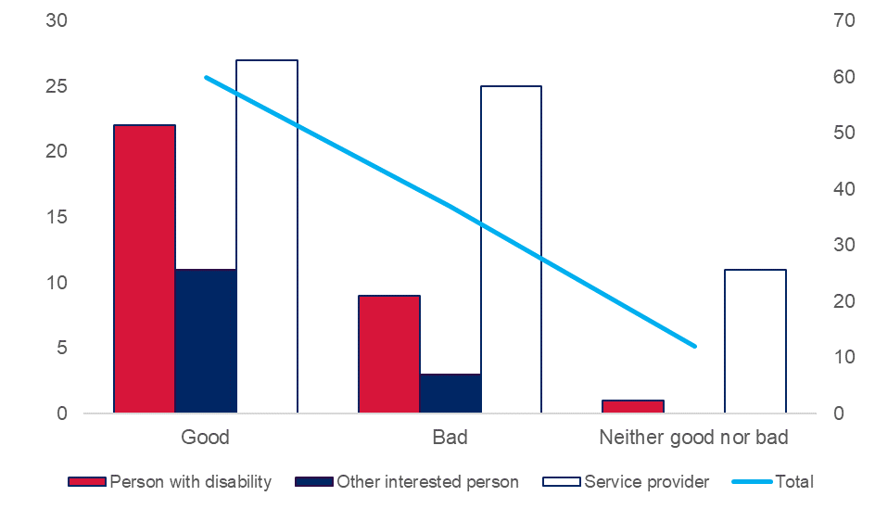
The persons with disability and other interested persons who said they were involved in giving consent said that this was better than the experience of participating in RPA decisions generally.

I liked having a say.
– Person with Disability

Good to help family/carers better understand process and behaviour support alternatives.
– Other Interested Person

This was not the case for Service Providers, who reported good and bad experiences around consent in roughly equal numbers.

This was a good experience as many people including the customer were consulted. Everyone agreed that the RPA would be beneficial for the customer and the people they lived with.
– Service Provider

Bad in obtaining consent – lots of barriers in current systems, e.g. client with changeover in terminology on waiting list for getting consent; sometimes getting consent back from DCJ for kids is time consuming meaning many reportable incidents; makes whole process irrelevant and look silly – the whole safeguarding of process is undermined; either should be rectified or replaced.
– Service Provider

Figure 14 - Q7c: If yes, in what ways was the experience good or bad?
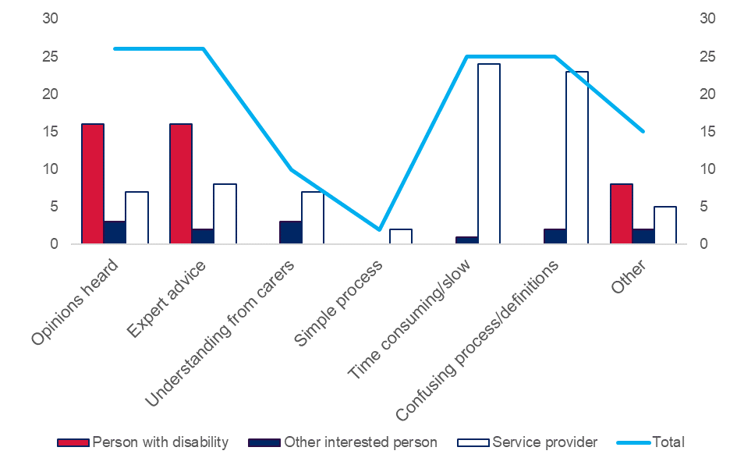
People who found the experience to be good tended to emphasise the opportunity to be heard and to access expert advice as part of the consent process.

Experience in obtaining from person responsible/guardian – usually done with behaviour support planning and spending time.
- Service Provider

Service providers who found the experience to be bad tended to emphasise the slowness of the process, risks around withholding or withdrawal of consent, and challenges engaging with institutional decision makers.
Service providers carry all the risk if consent is withheld, e.g. insurance issues, environmental factors, risks.
– Service Provider

We have had to apply with the person with disability for guardianship for the purpose of authorising an RPA. This does slow down the process and seems pointless, as the guardian is often following the recommendation of the organisation in this situation.
– Service Provider

Persons with disability and other interested persons who found the experience to be bad tended to report feeling disempowered, or that it was not truly an opportunity to be heard.

I was glad I was consulted but in some ways felt pressured to provide consent because otherwise the service provider would not transport my child or continue to provide care.
- Other Interested Person

Q8: How should consent be part of RPA?
There was strong support, from all perspectives, for consent to remain a mandatory part of RPA in NSW. Some respondents specified that RPA should not be required in emergencies. The current policy and legislative framework deals with this by unauthorised use of restrictive practices in an emergency being a reportable incident.
Figure 15 - Q8: How should consent be part of RPA?
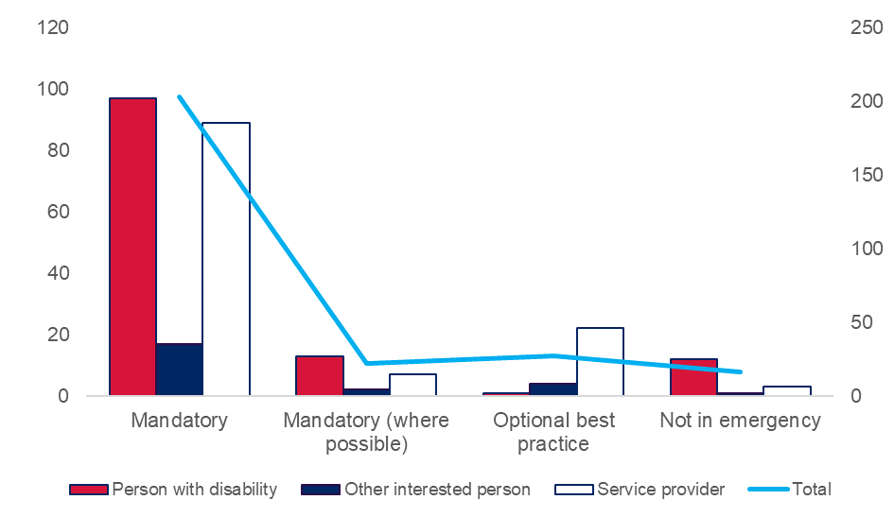
A minority of respondents wanted to increase flexibility around RPA by defining circumstances where this requirement might be waived, or treated as optional best practice. This tended to be in response to practical difficulties with obtaining consent, or where safety concerns are especially acute.

Optional good practice as some of our participants have disengaged family or have the public guardian who will only give consent after the fact.
– Service Provider

Required - although if serious safety issues, the panel itself should have some power to consent also.
– Service Provider
Figure 16 - Q8: How should consent be part of RPA?
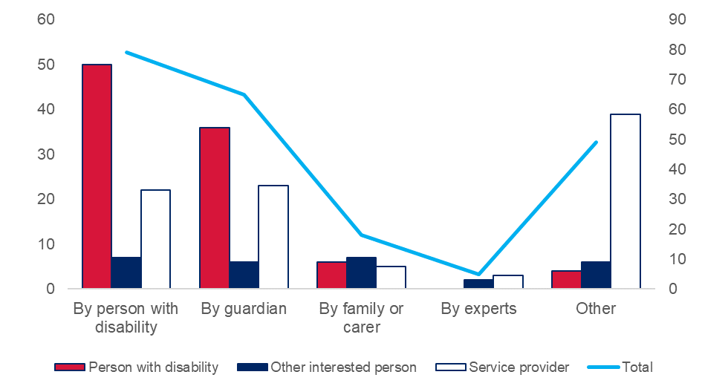
There was strong support, from all perspectives, for persons with disability who have the capacity to do so to consent directly to the use of RPA, including where a person with disability might need support to make or communicate a decision about consent.

The participant needs to provide consent as well as legal guardian and advocates to ensure that this is the most appropriate and least risk option available at the time.
- Person with Disability

A minority of persons with disability expressed a preference that others be responsible for making decisions about consent on their behalf.

One participant felt more comfortable if other people were making the decision because he does not want to return to jail. One participant said he’s not worried because ‘they will make the decision anyway’.
- Person with Disability

Despite a preference for direct or supported decision making by persons with disability, guardians were accepted as substitute decision-makers by most respondents where the person with disability does not have the capacity to decide for themselves.

Consent by a carer/guardian (when the person is not able) should be required. If a person has no guardian, then perhaps someone with a true interest in their welfare and a knowledge of them or at least a good knowledge of the nature of their disability should be sought.
– Other Interested Person

Consent should be required either from the person, if they have the capacity to do so, or their families.
– Service Provider
Many service providers responding to this question raised operational challenges associated with administering consent, particularly when working with institutional decision makers.

Standardise definitions; NCAT refuse consent because RP didn’t mean their definition of an RP.
- Service Provider

Some service providers also raised operational risks around withdrawal or withholding of consent, as well as the effect of resource constraints on efforts to obtain informed consent.

It’s difficult to work within withholding consent and explaining consequences of not consenting, this could come across as forcing consent.
- Service provider

Q9: What support do you need to give consent (for Persons with Disability); or to give consent on a person’s behalf (for Other Interested Persons); or What support or guidance do service providers need to manage consent (for Service Providers)?
Figure 17 - What support do you need to give consent; or to give consent on a person’s behalf; or What support or guidance do service providers need to manage consent?
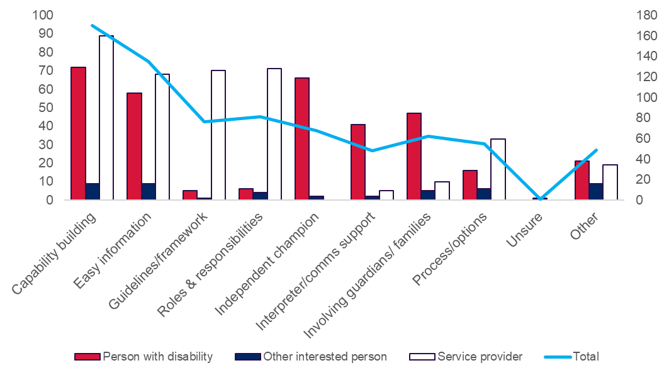
There was a strong desire, across all perspectives, for more capability building and easy information around consent for RPA. Consent is a complex and sensitive matter, which requires decision makers to balance competing rights and interests. It also interacts with other legislative frameworks, including the Guardianship Act 1987.

Be provided with clarification on who legally can give consent on the behalf of a participant (e.g. legal guardian). Be provided with clarification on what consent looks like (e.g. template of a consent form). Be provided with information around wording and time frames.
– Service Provider

I can't read very well. So I like to have easy read information. I can understand this better.
– Person with Disability

Responses from service providers expressed strong themes around desire for clarification of guidelines and frameworks, as well as roles and responsibilities for obtaining consent. Although pressing priorities for service providers, these were seldom raised as concerns by persons with disability or other interested persons.

Service providers need to be given clear information and guidelines about the use of restrictive practices. Be provided with options and flowcharts for different practices and options. Easier access to behaviour support plans and providers.
- Service Provider

Responses from persons with disability expressed strong themes around desire for support from independent champions and, to a lesser degree, guardians and families, as well as for support to communicate their wishes. In some cases, support to make and communicate their own decisions included having enough time to consider information before needing to decide.

Clear understanding of what is involved and given the support of a paid advocate, to explain the processes and given time to build this capacity to understand.
- Person with Disability

When I am under pressure I don’t make good decisions.
- Person with Disability

Where should RPA be required?
The Consultation Discussion Paper introduced the idea that persons with disability may need behaviour support in many different settings or places, like home, work, school, hospitals, outside, and when receiving services from NDIS providers. Restrictive practices could be used in any of these settings, but only some settings need authorisation under the interim NSW RPA Policy.
The current model is only for NDIS providers delivering services to NDIS participants. Some settings have different frameworks for when they can use restrictive practices, like hospitals, schools, prisons, aged care facilities, and out-of-home care. In other settings, like public places or family homes, there are no frameworks for restrictive practices.
The Consultation Discussion Paper explored three broad themes in this section:
- In what settings should RPA be required?
- Should one authorisation apply across more than one setting?
- How should we make RPA more consistent?

Recommendations
- Expand the scope of settings where RPA is required.
- Harmonise RPA principles across institutional/professional settings.
- Liaise with the Australian Government to encourage collaboration around behaviour support.
- Facilitate, but do not require, authorisation across settings.

Discussion

Q10: In what settings should restrictive practices need to be authorised before they can be used?
There was strong support, from all perspectives, to expand the scope of RPA regulation in NSW beyond NDIS providers delivering services to an NDIS participant.

Restrictive practices should be authorised in any setting. People should not be stopping people with disability from doing things if they have not been given permission.
- Person with Disability

Some respondents said that restrictive practices should never be authorised for use with a person with disability.

Restrictive practices should not be used at all.
- Other Interested Person

Figure 18 - Q10: In what settings should restrictive practices need to be authorised before they can be used?
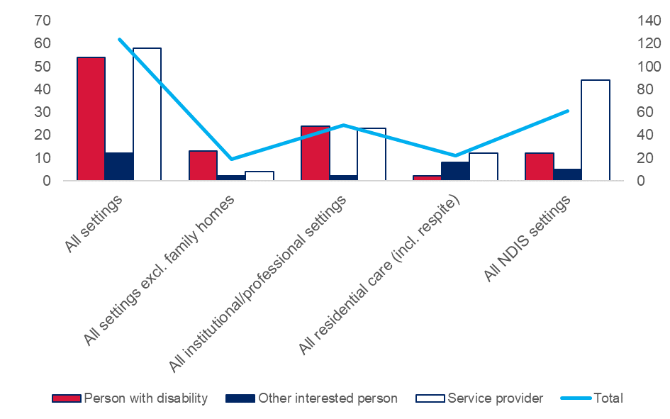
The most common response to this question was that restrictive practices should need to be authorised before they can be used in all settings.

RPA is for behaviour, not a setting (Location). They should, therefore, be approved based on the behaviour and available for use in multiple locations if the behaviour presents without additional approvals. The RPA is linked to the client, not the location of the client.
– Other Interested Person
Some respondents wanted RPA to be required in all settings except the family home, or in all institutional settings.

Ideally all, but understanding that settings such as at home can be difficult to monitor.
– Person with Disability

Institutional settings and community settings appropriate for formal authorisation process.
– Service Provider

The majority of respondents from all three perspectives wanted to expand the scope of current RPA regulation in NSW to more settings because they believe that this will better safeguard the rights and wellbeing of persons with disability.

Our staff in ACT are reporting positive changes in supports for the individual where RPA occurs across both school and disability settings.
- Service Provider
Figure 19 - Q10: In what settings should restrictive practices need to be authorised before they can be used?
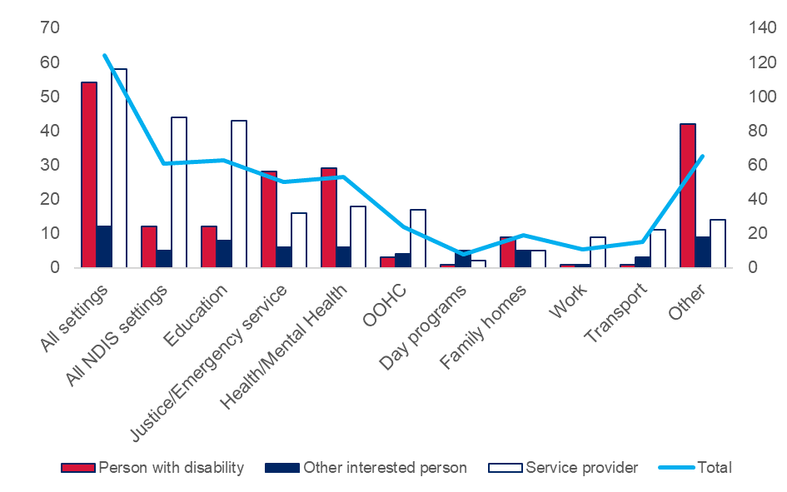
Specific settings that were commonly suggested for RPA regulation to apply included most government-run health and human services. A minority of respondents wanted RPA to apply in family homes.

Schools should absolutely need to go through this process. Some of the RP are created for the benefit of the teachers not the child.
– Service Provider

Emergency services, health and justice should definitely have an authorisation process.
– Person with Disability

I want it to be required for schools, inside families when the disabled person is young or doesn't reasonably have a way to escape and live on their own, for any care organisations or supported living or aged care situations. Any disability services should have the same protections that NDIS funded services do, but with improvements.
– Person with Disability

In group homes, day programs and respite centres. I believe it should also be a requirement for family members as many carers do not understand the long term implications of using RP's inappropriately.
– Other Interested Person

Q11a: Does more than one provider use restrictive practices with you (for Persons with Disability); or with a person you care for (for Other Interested Persons); or Do you provide services to a person who has restrictive practices from more than one provider (for Service Providers)?
Most respondents said that they have experience of restrictive practices being used or authorised for a person with disability across more than one setting.
Figure 20 - Q11a: Does more than one provider use restrictive practices with you; or with a person you care for; or Do you provide services to a person who has restrictive practices from more than one provider? 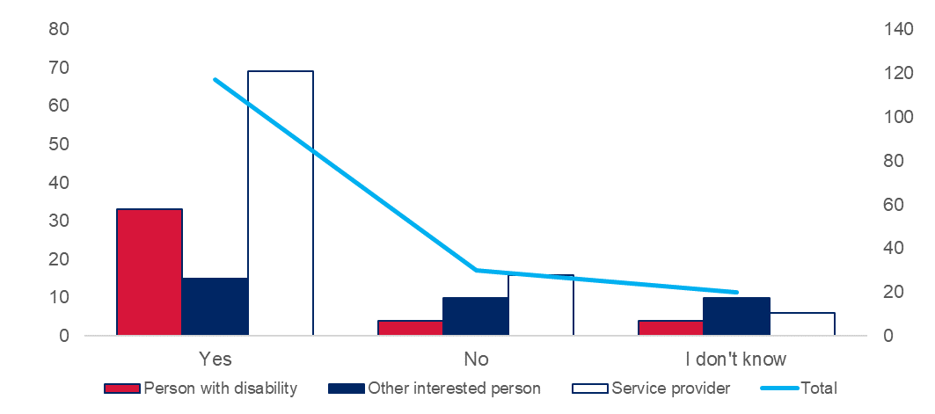

Q11b: If yes, how well does RPA work across settings?
Most respondents with experience of RPA across settings reported that this does not work well under the current system.
Figure 21 - Q11b: If yes, how well does RPA work across settings?
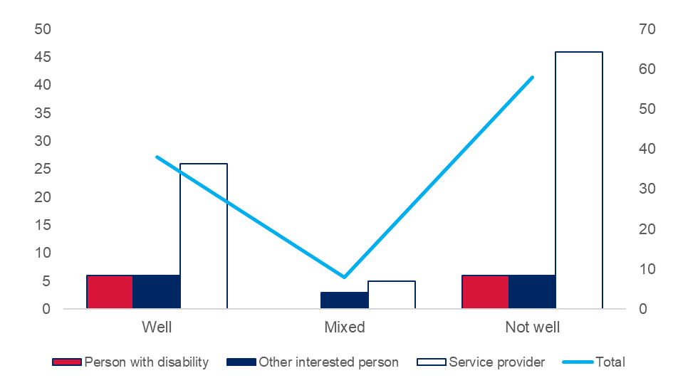
Figure 22 - Q11b: If yes, how well does RPA work across settings?
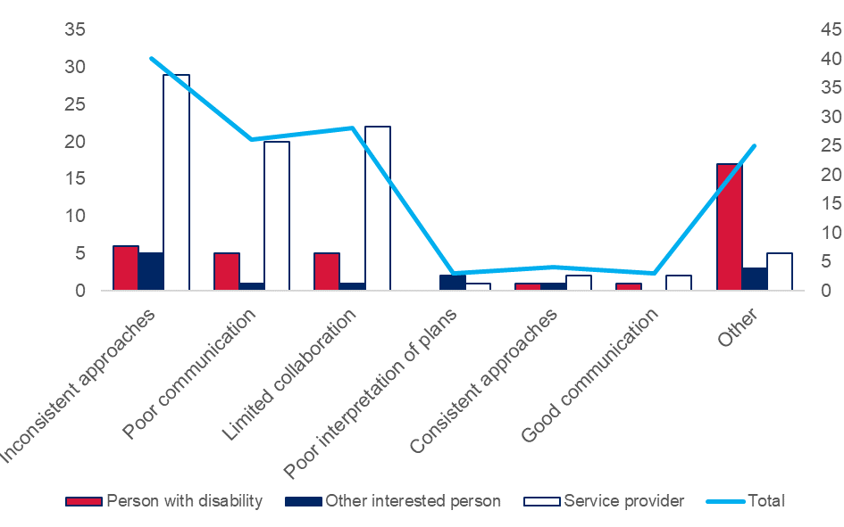
The most commonly cited problems under the current system were inconsistent approaches, poor communication, and limited collaboration.

There is a big disconnect between settings - there may be some participants who have multiple RPs in SIL, but none in day program or vice versa - means the supports are very different and inconsistent.
– Service Provider

The biggest challenge to restrictive practice authorisation across settings is consistency as there is little to no communication between settings to discuss what is or has been used. This is particularly notable when comparing settings such as an NDIS service provider which is proactive in authorisation, versus emergency services which is reactive to the immediate circumstance.
– Person with Disability

Service providers raised limited resources in NDIS plans as a key contributing factor to all of these issues, both for service providers and for participants and guardians.

Consistency for any behaviour support across settings is always a challenge – more funding for implementation is needed in their improved relationships, funding is often needed for this to be implemented and monitored well.
- Service Provider

This is a contributing factor of participants and guardian not attending panel – as they might have to attend 3-4.
- Service Provider

A minority of respondents reported consistent approaches and good communication across settings, although some noted that this can be a function of individual efforts rather than systemic incentives for collaboration.

Generally, there is consistency across settings when communication is strong between different organisations, e.g. between group home team leader and day service coordinator. However, this is not always the case depending on staff.
- Service Provider

Q11c: If yes, how would this change if restrictive practices were authorised across settings?
Despite reporting that RPA does not work well across settings now, many respondents, particularly among persons with disability, said they did not want a single authorisation to apply across settings.

The local and personal focus could change and I would not have the same person centred approach to my needs.
– Person with Disability

While we recognise the safeguarding function of the RPA process, our experience with families/carers suggests that a “one size fits all” approach may actually reduce the effectiveness and person-centredness of the process. Flexibility in systems may promote more collaboration, education and understanding.
– Service Provider

Figure 23 - Q11c: If yes, how would this change if restrictive practices were authorised across settings?
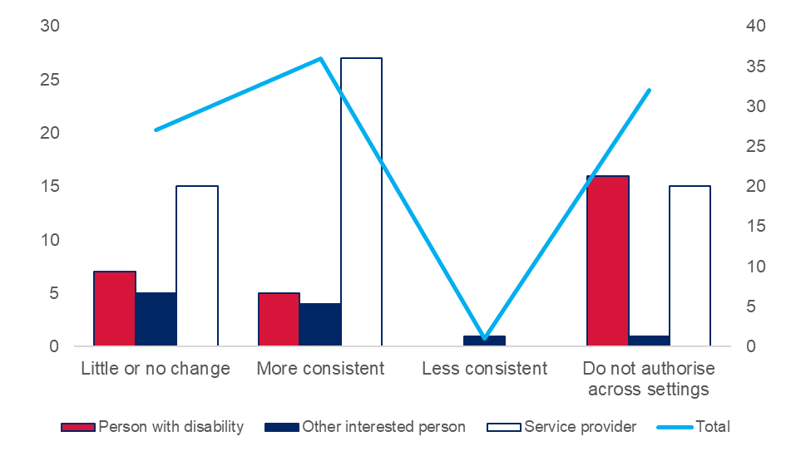
Many respondents stated that authorisation across settings would improve consistency, although others thought it would not make much difference.

More consistency leading to better outcomes.
- Other Interested Person

I don’t think it will – we will still need funding for implementation.
- Service Provider
Service providers raised a number of concerns about how authorisation across settings would work in practice, particularly with regard to resource constraints and operational challenges.

Big differences across settings around assessing and framing ‘risk’ which might affect authorisation decisions. More regulation may not help – the more unfunded expectations of organisations, the more their priorities will change, and the load will fall on other settings. Limited funding for BSPs and training – expanding scope of BSP across settings means more funding and time and training.
– Service Provider

Resources and funding unfortunately, should be best practice but services are stretched - not $ allocated for panel.
– Service Provider

Figure 24 - Q11c: If yes, how would this change if restrictive practices were authorised across settings?
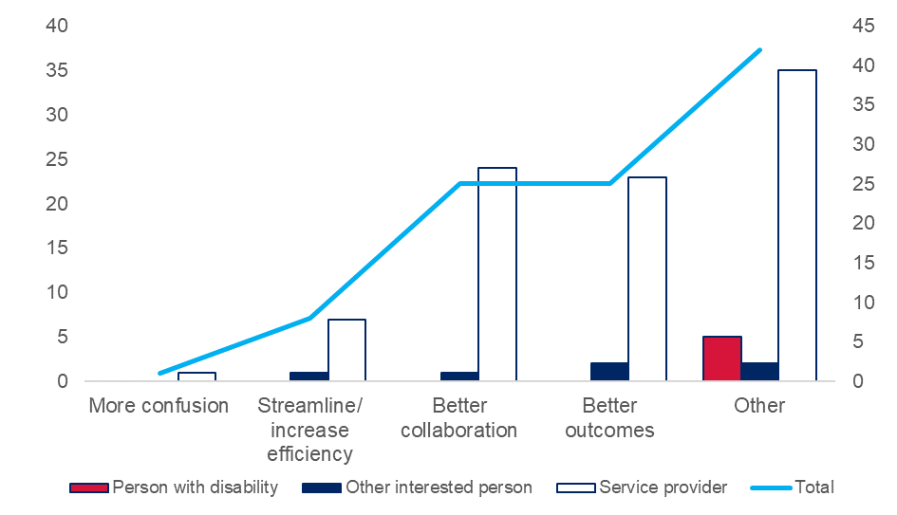
Despite describing significant operational and resourcing challenges to RPA across settings, many respondents, including service providers, thought that authorisation across settings would improve collaboration and outcomes for persons with disability.

The group noted that there would be difficulty transferring the current NDIS process of RPA, however ensuring that the same RPA principles are enforced that this would help in consistency.
- Person with Disability

If they were authorised across settings this would mean more cohesive supports.
- Service Provider

Q12: In what settings should we use the same RPA principles for people with disability?
Respondents expressed a strong desire to harmonise principles across all settings in which practices that are restrictive are, or could be, used to support persons with disability.

Principles should be streamlined and consistent across all settings to limit the opportunities for confusion.
- Person with Disability
Harmonising principles was regarded by some respondents as a less intrusive and disruptive way of improving consistency and safeguarding, without needing to adopt the same RPA process across all settings.

A tiered approach to where RPA is required across settings would also be welcomed. Potentially disability and education settings could be the highest tier with the same processes, whilst health and justice settings are guided by the same principles, rather than needing the same process.
- Service Provider

Figure 25 - Q12: In what settings should we use the same RPA principles for people with disability?
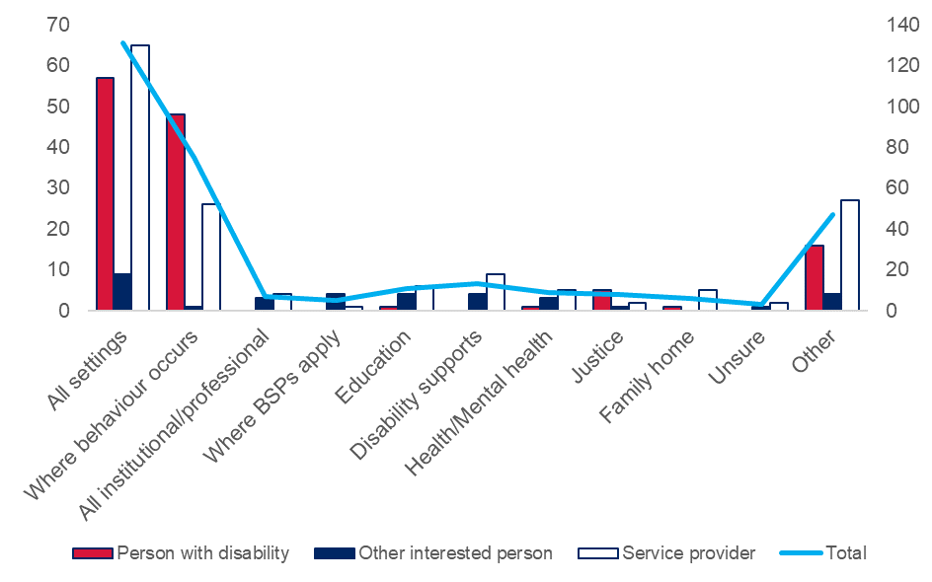
Persons with disability were less likely to think about RPA principles through the framework of settings in which regulation might or might not apply, and more likely to think about it as being about risks from behaviours of concern. This different framing appears to have influenced the strong theme around applying RPA in all settings where a behaviour occurs in the responses from persons with disability.

When the individual is at risk of self-harm or causing harm to others.
- Person with Disability
Some respondents named examples of settings where they think consistent RPA principles should be used.

To be effective, the regulation of restrictive practices needs to cover the use of restrictive practices in a range of settings. Especially given that people with disability may be subjected to restrictive practices in a variety of contexts, including: supported accommodation and group homes; residential aged care facilities; mental health facilities; hospitals; transport; prisons; and schools.
– Other Interested Person
Other respondents gave examples of cases where common principles, well understood, could have improved outcomes for persons with disability.

The police need training. A girl I knew gave the policemen a card to say she had an intellectual disability and he just threw it away.
- Person with Disability

Q13: In what settings should we use the same RPA process for people with disability?
Service providers and other interested persons had an appetite to adopt consistent RPA processes across more settings.

We don’t want difference and inconsistencies across environments – this makes it more difficult and confusing for the person, and doesn’t have great outcomes where in one environment one response is ok, and in another it is not.
- Service Provider

Some persons with disability expressed similar views about the benefits of consistency.

It is easier to understand things when there is the same routine.
- Person with Disability
Figure 26 - Q13: In what settings should we use the same RPA process for people with disability?
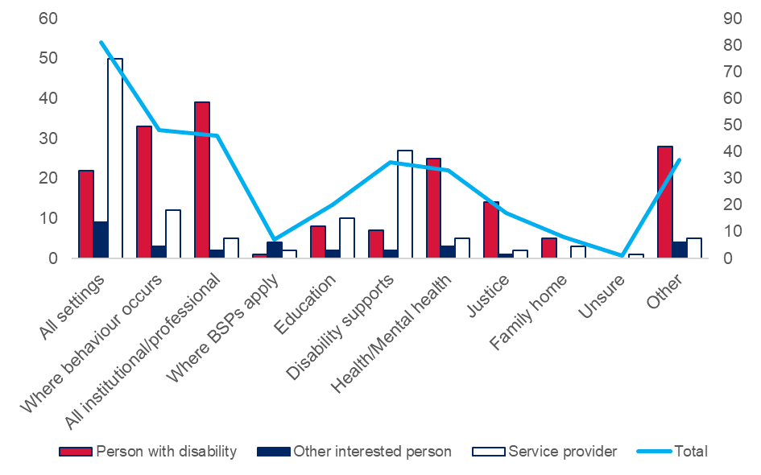
More persons with disability, however, wanted to adopt consistent RPA processes only in institutional/professional service settings, including health and mental health services, and justice settings.

Non-emergency hospital/health settings. The group did not feel that any other settings would be realistic for the same RPA process, and should be reviewed on a case by case basis.
- Persons with Disability

Persons with disability again displayed a preference in their responses to this question for thinking about regulation of restrictive practices in terms of managing risk safely around behaviours, rather than in environments that may or may not be regulated.

Where there is a valid need to protect an individual and allow a good quality of life.
- Person with Disability
Some persons with disability expressed the view that more specific, local Behaviour Support Plans and RPA are better.

Behaviour plans should continue to be specific and small in scope. There should be some friction to broaden them at all and it should always be as specific as possible.
- Person with Disability

Q14: When should one authorisation for a restrictive practice apply across settings?
Figure 27 - Q14: When should one authorisation for a restrictive practice apply across settings?
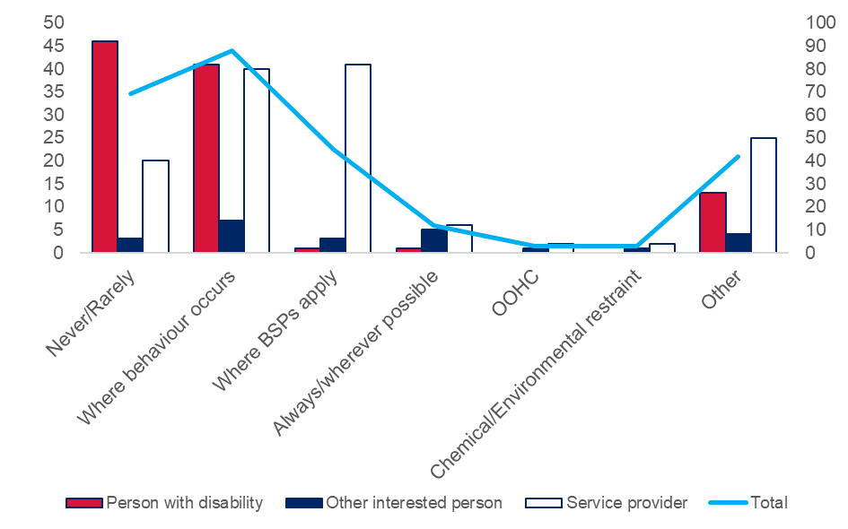
Most persons with disability either did not want single authorisations to use restrictive practices across settings, or wanted this only where the same behaviour of concern poses similar risks.

I feel there needs to be individual RPA for each setting as different environmental settings can have a huge impact on how an RPA would be developed and implemented.
- Person with Disability

Some persons with disability expressed concern that a single authorisation could increase the risks associated with a bad decision.

The group did not feel that one authorisation across all settings would be safe for the consumer, as this had more opportunities for it to be abused. This should be setting dependent.
- Person with Disability
Service providers and other interested persons were more likely to support a single authorisation to use a restrictive practice where the same behaviour of concern occurs across settings.

In instances where a strategy is being used to manage the same specific behaviour of concern.
- Service Provider
Service providers tended to link this idea to the Behaviour Support Plan: where the same plan is being used, a single authorisation could apply, with potential benefits for consistency and efficiency.

Potentially the panel that goes across multiple environments should then have a rep from each environment – instead of 2-3 panels occurring separately.
- Service Provider

Q15: How should we make RPA more consistent across settings?
There was a strong desire to improve consistency of RPA to be more consistent with a rights-based framework.
Figure 28 - Q15: How should we make RPA more consistent across settings?
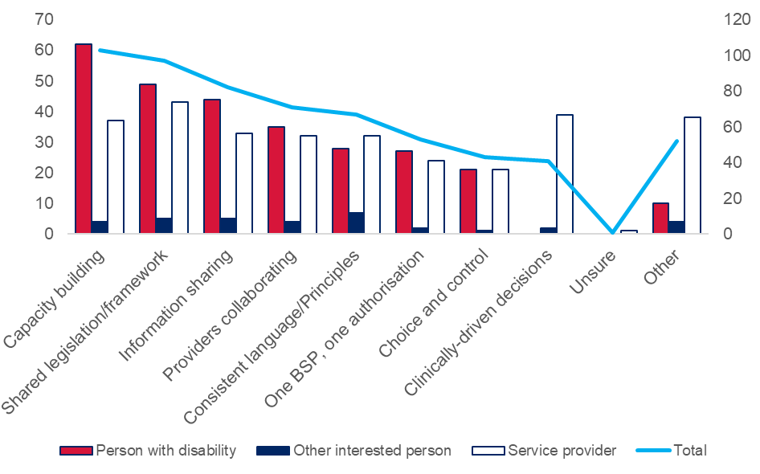
Capacity building, a common regulatory framework, and information sharing/collaboration were strong themes across all three perspectives.

Consistency across settings could be achieved through the development of a legislative framework comprising guardianship-type laws and regulations (or a separate and distinct legislation dealing specifically with restrictive practices), developing and implementing common standards and shared and sustained leadership, as well as embracing data-driven continuous improvement.
– Other Interested Person

Fewer service providers emphasised capacity building than did persons with disability, for whom this was the strongest theme.

Each place should have support to fix up their panel and practice rights.
– Person with Disability

Streamline the processes and policy so that they are all consistent with human rights protections, trauma-informed care, and recovery orientated. There should be universal training and standards for health care professionals implementing this practice.
– Person with Disability

Some respondents identified the need for investment and targeted resources to improve consistency.

Include funding in NDIA plans to support collaboration across settings - with client’s consent. Same definitions across all settings - with examples given to help understanding.
– Other Interested Person

Make more consistent use of Independent Specialists and improve their consistency with each other.
– Service Provider

Who should make decisions about RPA?

Recommendations
- Continue to empower local panels to make RPA decisions.
- Continue to require current minimum skills and experience for RPA Panel members.
- Continue to require current conditions for RPA.
- Introduce a formal process to appeal RPA decisions in NSW.
- Empower persons with disability, or their guardians, to appeal for a formal review of an RPA decision.
- Establish independent central panels to consider appeals.
- Maintain current monitoring mechanisms.
- Liaise with the Australian Government to align enforcement powers.
- Consider light touch legislation, supported by a NSW strategy and/or policy framework.

Discussion

Q16: Who should authorise use of a restrictive practice?
There was strong support among respondents for NSW to continue to operate a model based primarily on local panels making decisions about RPA. This included many respondents who wanted a mix of central and local panels to make different types of decisions under different circumstances.
Figure 29 - Q16: Who should authorise use of a restrictive practice?
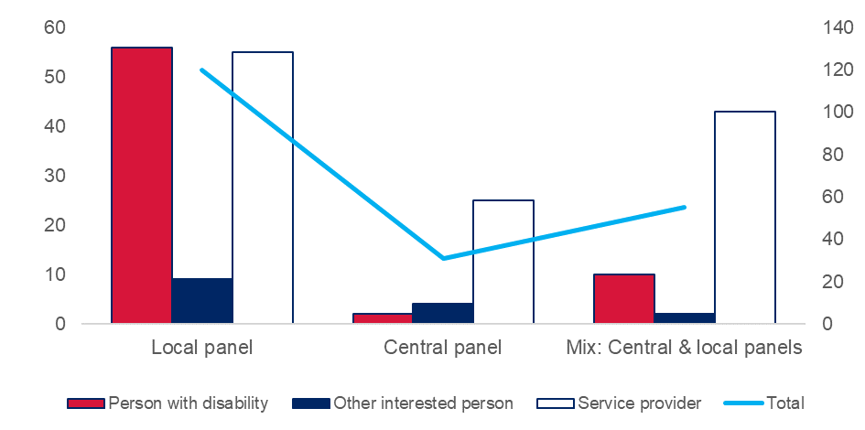
This theme was consistent across the three different perspectives. Some respondents said that there should be exceptions in emergency situations, which is consistent with current NSW RPA Policy.

There should be an authorised local panel, unless it is an emergency, where a Doctor could authorise where there is a risk of life or harm.
- Person with Disability

More persons with disability wanted local panels to make decisions about RPA, often because a local panel is likely to include decision makers who know the person with disability and their support needs.

I don’t want someone who doesn’t know me making the decisions.
- Person with Disability

Service providers tended to prefer local panels because they offer greater flexibility and perceived timeliness, as well as relevant operational insight.

Local – sometimes needed quickly to ensure safety for all.
- Service Provider
There was also support, particularly among service providers, for a mix of central and local panels. In a mixed model, central panels were variously proposed to handle more complex cases, authorisations across settings, specialist or highly technical cases, and appeals or reviews.

A tertiary or more centralised panel could consider people with complex needs or act as a resource for local panels. There may also be merit in RPA panels that have a specialisation in a particular cohort of people. For example, a panel with expertise in considering RPA for children and young people may be able to make more nuanced decisions about the restrictive practice and the monitoring of these within developmental frameworks.
– Service Provider

I agree with the current arrangement of panel members (independent, behaviour expert, operational) however if a practice is high risk or long term (in place for 3+ years) I feel that an independent panel should convene to review and ensure this is the most appropriate and least restrictive practice available.
– Service Provider

Any compliant panel, which could be a single provider, a group of providers, a central panel, or a regional panel operating across settings.
– Service Provider

In line with person centred practice, there should be flexibility. Local processes (as current) are easier but there should be one mandatory objective party such as FACS staff on the panel. A more formal panel (such as the Mental Health Review Tribunal) should be made available when there is concern from behaviour practitioner, family or service that local processing is not appropriate and/or there has been conflict between stakeholders, and/or there is suspicion of under-handed practices occurring.
– Service Provider

Albeit in smaller numbers, some respondents preferred central panels as the primary decision-making forum for RPA to ensure access to expertise and to avoid actual or perceived conflicts of interest.

Expression of interest for panel members could be called state-wide to ensure wide-spread skills and avoid conflict of interest.
- Service Provider

It should be an entirely independent panel of experts, including a person with disability, that is able to consider all information and evidence objectively.
Person with Disability

Some respondents used this question to indicate the types of people they thought should be involved in making decisions, rather than the forums within which decisions should be made. There was strong support from all perspectives for the person with disability, or another person with lived experience, to be part of the decision to authorise use of a restrictive practice.
Figure 30 - Q16: Who should authorise use of a restrictive practice?
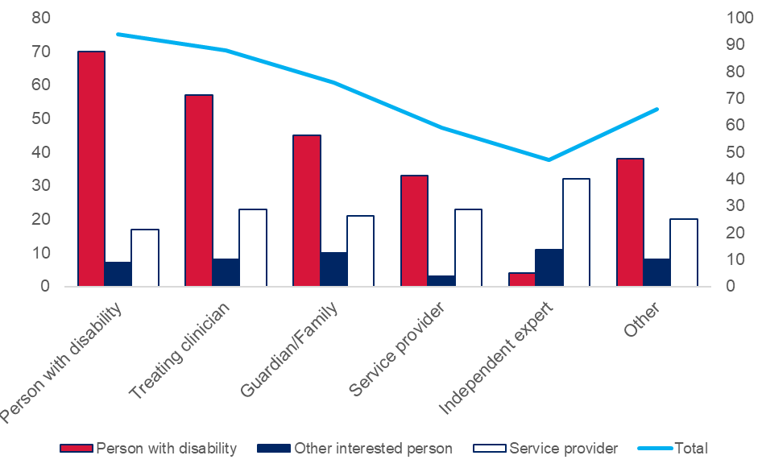
Persons with disability wanted to be involved in authorisation decisions, along with their treating clinicians and guardian/family.

The actual person, they know how it will affect them and it’s about them.
- Person with Disability

- A consumer’s direct treating professional
- Peer support worker
- Support service provider

- Person with Disability

Parents and people who live in the group home.
- Person with Disability

Service providers tended to emphasise roles for independent experts, service providers, and treating clinicians in authorisation decisions.

The use of regulated restrictive practices should be authorised only by a panel of qualified representatives, including NDIS providers or NDIS planners. Panel members may be comprised of internal and external providers, however the role of an independent panel member should be maintained to ensure transparency, integrity of decision making and management of real or potential conflicts of interest.
– Service Provider

Q17: What skills and experience should decision makers have?
Most respondents indicated that decision makers should have behaviour support and clinical skills and experience. This suggests that most respondents think about RPA as a safeguarding approach more in line with clinical governance than with more legalistic frameworks, although some respondents did identify legal/human rights skills as being relevant.
Figure 31 - Q17: What skills and experience should decision makers have?
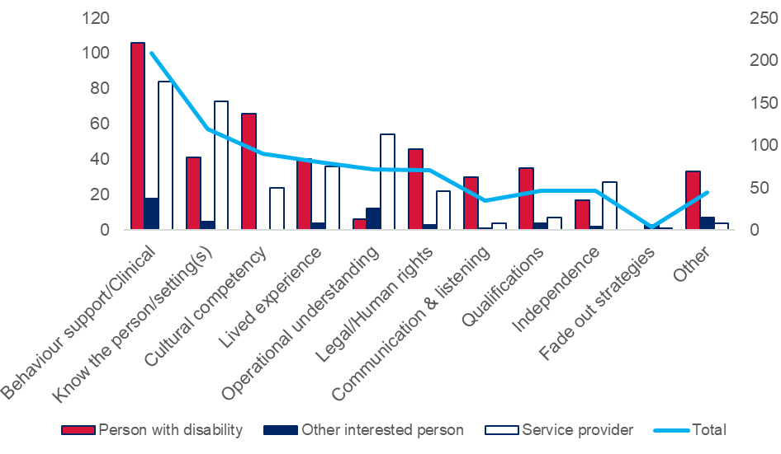
Behaviour support/clinical skills were identified by most respondents as skills required of decision makers authorising the use of restrictive practices.

Be a professional in the field of behaviour and disability diagnosis types and have experience in local community.
– Person with Disability

Experience in behaviour support and disability support in settings relevant to the settings intended for implementation.
– Service Provider

Medical advice - for chemical restraints, physical and mechanical (suits, splints, etc.)
– Service Provider

Many service providers felt that knowledge of the person/setting and operational understanding were important skills and experience for decision makers.

As the convenor is a senior manager highly familiar with the service setting where the restrictive practice is being implemented, this also allows them to have a comprehensive understanding of the complexity and nuances of issues surrounding authorisation through the decision-making processes.
- Service Provider
Persons with disability felt that cultural competency, legal/human rights skills, and lived experience were important skills and experience for decision makers to have.

Aboriginal cultural knowledge and local customs.
– Person with Disability

Strong understanding of rights and their own experience of either mental health issues, or a history of working with people who do.
– Person with Disability

I have an intellectual disability and I think I could help people.
– Person with Disability

Persons with disability also expressed a desire for decision makers to have particular personality characteristics, including good listening and communication skills, and being kind and sympathetic.

A nice, kind and gentle person. People should know me. The people from ADHC didn’t know me. They should make me feel safe and calm.
- Person with Disability

Q18: What conditions should be met to authorise use of a restrictive practice?
Figure 32 - Q18: What conditions should be met to authorise use of a restrictive practice?
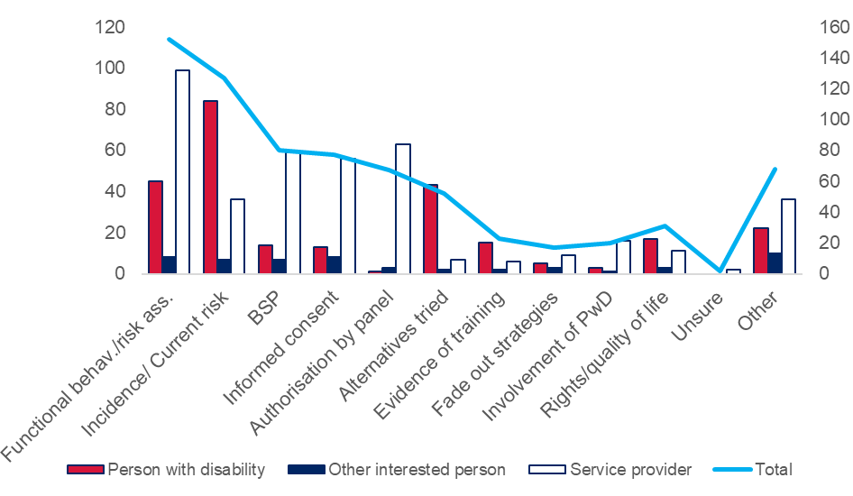
Service providers and other interested persons reinforced the current requirements, such as a BSP based on a functional behavioural assessment, informed consent, and authorisation by an RPA Panel.

I agree with: 1) A Behaviour Support Plan includes information about the restrictive practice and meets the standards set by the NDIS Commission; 2) Authorisation is given by a Restrictive Practices Authorisation Panel (RPA Panel); 3) Informed consent is given by the participant or their guardian.
– Service Provider

Persons with disability wanted to require evidence of current risk due to behaviours of concern and less restrictive alternatives tried as part of the conditions for authorisation.

Evidence that there is a significant safety risk on a longer-term basis – must be a pattern of behaviour, not one off.
- Person with Disability

Evidence of other measures used and why they didn’t work/why an RP would be the best option.
- Person with Disability

Q19: What information should decision makers use when deciding whether to authorise use of a restrictive practice?
Figure 33 - Q19: What information should decision makers use when deciding whether to authorise use of a restrictive practice?
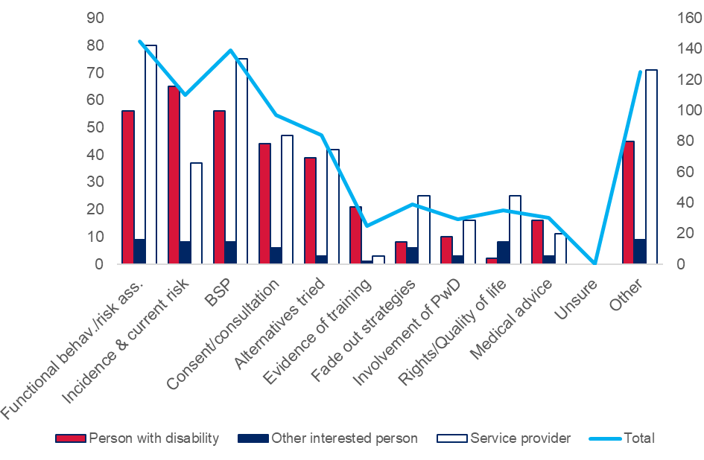
Most answers suggested by respondents are part of the information supporting RPA decisions under the current interim policy, e.g. functional behavioural analysis, recent evidence of the behaviour, and a Behaviour Support Plan.

Evidence of need for practice, evidence that other options have been considered and the proposed is the least restrictive, consent, behaviour plans.
– Service Provider
Current and relevant history of behaviour – one example is that some PWD may have aggressive tendencies when they are off medication, but not in other circumstances. This context should be part of the information provided.
– Person with Disability
As much information about the individual circumstance that is relevant to understand the behavioural needs of the individual.
– Service Provider
Persons with disability and service providers also felt that evidence of consent or consultation with the person, and alternatives to the proposed restrictive practice that have been tried should be provided to decision makers.

Consumer point of view has significant weight.
- Person with Disability

Plans developed with input from all interested parties. Strategies that have been implemented and why they didn’t work. The outcome sought for the client and people they may live with. The consent from lawful guardians and the client.
- Service Provider

Q20: What support and advice do decision makers need to do their jobs well?
Figure 34 - Q20: What support and advice do decision makers need to do their jobs well?
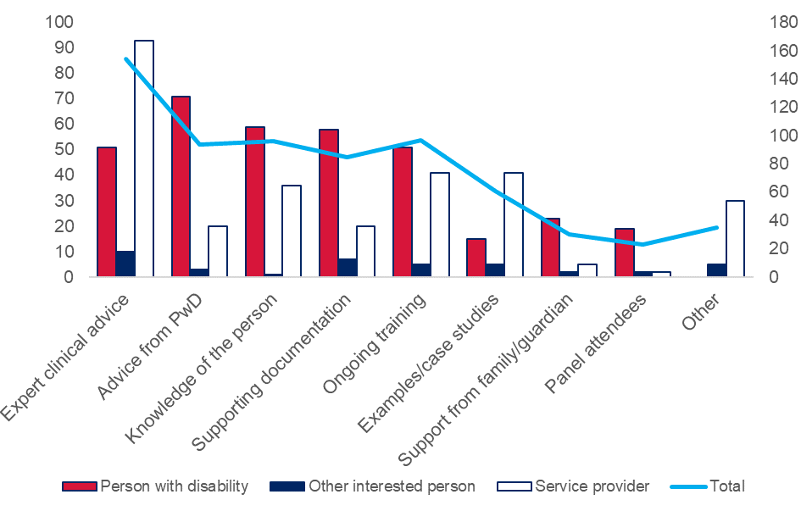
More persons with disability put high value on experiential support for decision makers to know and understand the person, e.g. advice from persons with disability, and knowledge of the person.

Listen to people who have experienced RPA, advice from people that work day to day w/ PWD
- Person with Disability

They really need to come from a basis to listen and hear, know the medical reports or any incident reports from the health, justice and education avenues.
- Person with Disability

Other respondents put high value on technical support for decision makers, e.g. expert advice, ongoing training, and examples/case studies.

Decision makers need to be really up to speed on alternate methods of practice that could be used with a participant rather than employing a restrictive practice. A central hub of ideas and examples would be great.
– Service Provider

Training, guidance on best practice, expert advice, e.g. medical.
– Service Provider

Continued professional development (mandatory attendance at least 1 seminar / webinar organised by Central Body about industry standards / good practice).
– Service Provider

Q21a: Should authorisation decisions be subject to appeal or review?
There was strong support for the introduction of a formal process for appealing RPA decisions in NSW.
Figure 35 - Q21a: Should authorisation decisions be subject to appeal or review?
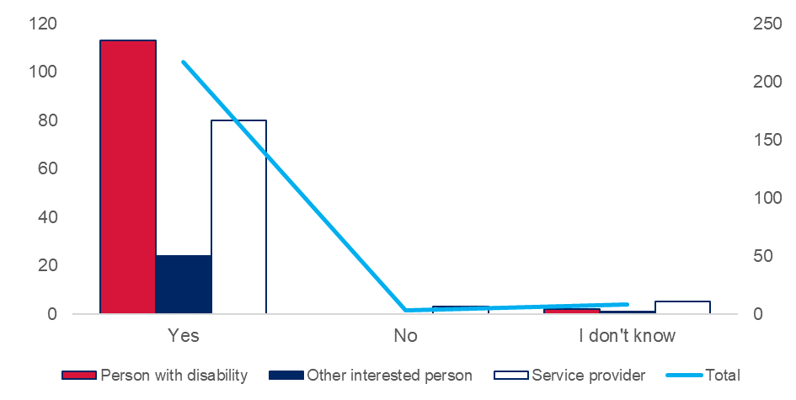

If people with intellectual disability are not happy with the decisions made they should be able to complain or ask for a review.
– Person with Disability

Agree with the right to appeal. It's so important and it feels as though this would be a great option before escalating to a complaint.
– Service Provider

From a procedural fairness perspective, an appeal process should be included.
– Service Provider

Q21b: If yes, when and how should this happen?
Figure 36 - Q21b: If yes, when and how should this happen?
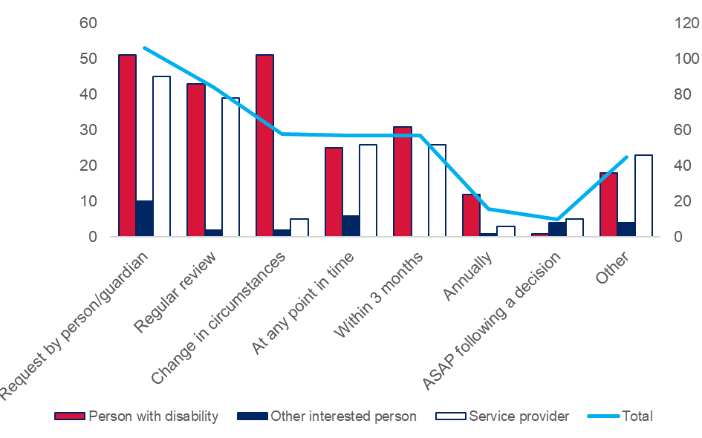
Persons with disability tended to express their preferences for when an appeal or review should be required, and how it should be triggered, rather than by the forum in which an appeal or review may be considered. There was a desire for decisions to be reviewed both as requested, and on a regular schedule.

If a consumer requests a review, appeal or withdraws consent - the authorisation for that restrictive practice to be used will immediately cease until a review decision is established.
– Person with Disability

These reviews should be done every three months, because personal supports and circumstances change in the disability service sector.
– Person with Disability

Individuals or guardians should always have the right to appeal.
– Service Provider

Figure 37 - Q21b: If yes, when and how should this happen?
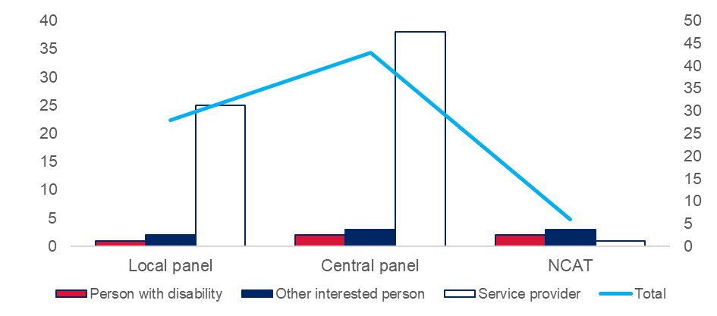
Service providers tended to express their preferences for how an appeal or review should be considered, and by what type of forum, i.e. a local or central panel.

At this stage, I think a more centralised model would be the most time and cost effective. It could also be an on-line review process if all the information was available.
– Service Provider

Some service providers raised concerns about the workload implications of a review process and made suggestions to ensure that effort invested in appeals is well targeted.

Pre-work should test whether there are reasonable grounds for an appeal, to avoid long processes where the decision is sound, e.g. where a family member wants to insist on a prohibited practice.
– Service Provider

Q21c: If yes, who should consider the appeal or review?
Figure 38 - Q21c: If yes, who should consider the appeal or review?
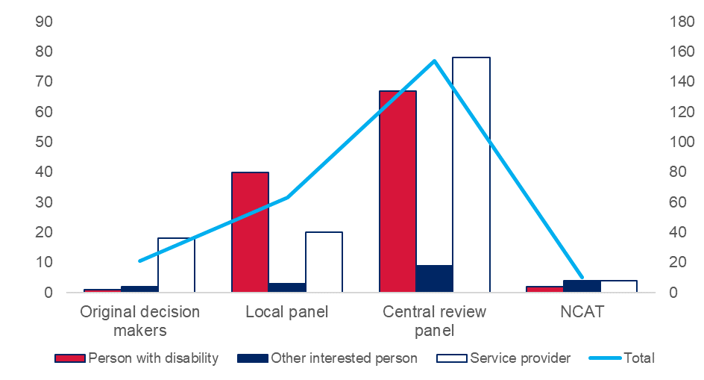
There was a consistent preference for independent central panels to consider reviews or appeals.

An independent and impartial review panel, no members can have any previous involvement with the consumer under review.
– Person with Disability

It can’t be inside the same organisation, even if the reviewer is independent.
– Service Provider

A central review panel should consider appeals. This would be less work for service providers, would be more independent, and would be highly skilled and more consistent in the views.
– Other Interested Person

Many persons with disability, however, talked about including new decision makers, but not necessarily through a central panel. This is consistent with a general preference among persons with disability for local decision makers who know the person.

Maybe another group of people. If it goes back to the same people then they might not change anything.
- Person with Disability

Support Worker of PWD should be part of the review.
- Person with Disability
Figure 39 - Q21c: If yes, who should consider the appeal or review?
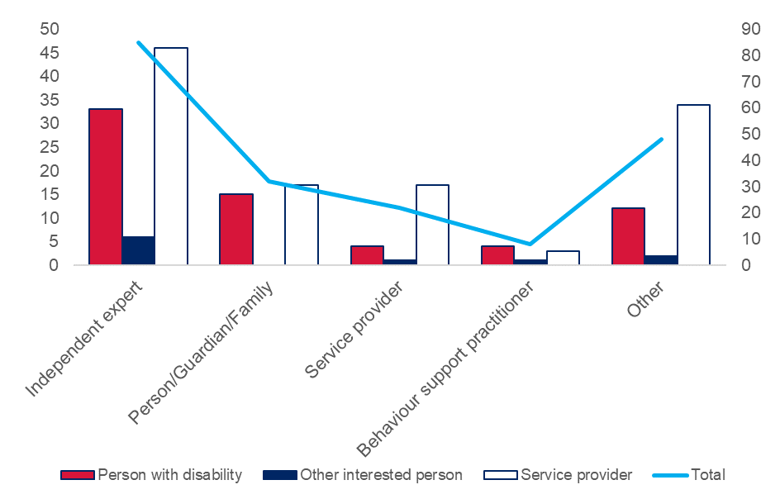
There was a strong preference for independent experts to be involved in considering reviews from all respondent types.

An independent and impartial review panel, no members can have any previous involvement with the consumer under review.
– Person with Disability

A more formal panel of independent professionals than the local authorisation panels.
– Service Provider

Q22: How should the quality and consistency of RPA decisions be monitored?
Figure 40 - Q22: How should the quality and consistency of RPA decisions be monitored?
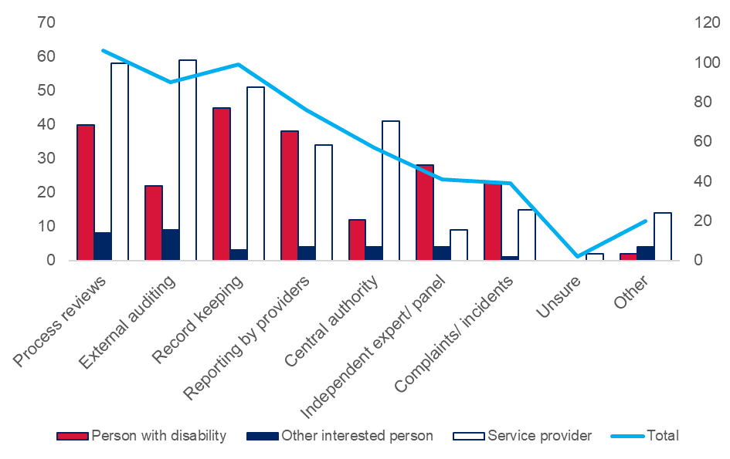
Most respondents indicated a preference for external oversight and auditing of processes and decisions, particularly among service providers. This included process review and external auditing, as well as proposals for routine oversight, e.g. by Independent Specialists who are funded by DCJ to participate in RPA Panels.

Central checking a sample to ensure that skills and process are appropriate.
– Service Provider

Although there is currently no external body auditing quality of decision-making processes, in this context, the independent specialist provides a level of independent oversight separate to the implementing provider.
– Service Provider

The Ageing and Disability Commissioner should check on restrictions. Check in every few weeks, ask the person if it's working or not.
– Person with Disability
Persons with disability tended to put greater emphasis on routine record keeping and reporting as a mechanism for oversight. Persons with disability were also more likely to value participation by independent experts as an oversight mechanism, including in response to complaints or appeals.

External review body with the sole purpose of monitoring.
– Person with Disability

Having an actual appeals committee like Dept of Housing has the Housing Appeals Committee, independent of the Housing body. They would be checking that decision makers have the right skills and information to make good decisions and checking some decisions to make sure that they were made in the right way.
– Other Interested Person

Q23: What enforcement powers should this include?
Figure 41 - Q23: What enforcement powers should this include?
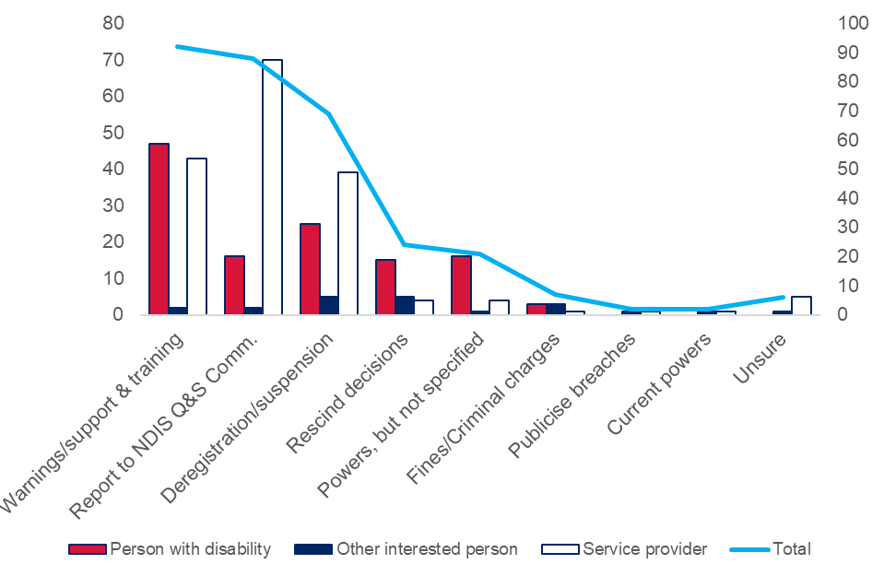
Respondents indicated a desire for a capacity building and supportive approach to improving RPA decision making, with the potential for an RPA Panel or RPA Panel member to be deregistered or suspended.

This independent body should be able to recommend training and set an example of a culture of best practice.
- Person with Disability

Enforcement could also be in a coaching model - making sure that enforcement is done in a way that helps organisations learn.
– Service Provider

Report to a Central Registration Board for Panel Members. Suspensions from panel until further training undertaken and skills assessed.
– Service Provider
There was also a desire among many service providers to align or combine enforcement powers with those of the NDIS Quality and Safeguards Commission.

Education and support as a first step, leading to Referral to appropriate stakeholders such as police or the NDIS Commission.
– Service Provider

- support
- supervision
- closure of panel
- report to the NDIS Q&S Commission
– Service Provider

Q24: What form should RPA regulation take?
Figure 42 - Q24: What form should RPA regulation take?
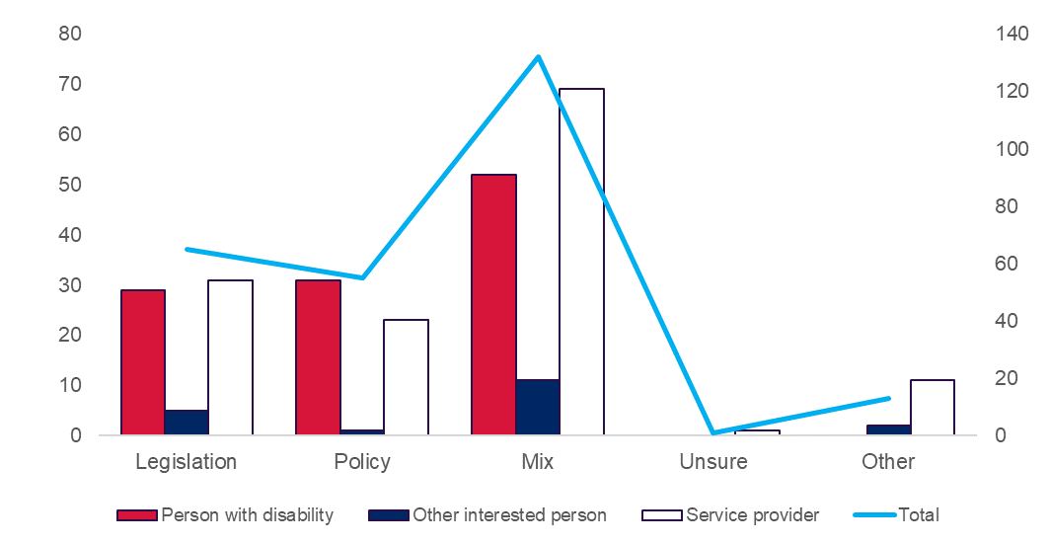
There was a preference for a regulatory approach that combines a platform of legislation to define principles and enforcement powers with a policy framework that enables flexibility. Flexibility was seen to be desirable to accommodate local variation, and scope for adjustment as the full-scheme NDIS matures, capability increases among decision makers, and more settings harmonise principles and work through implementation considerations.

A mix, as the setting from rural to remote and culture, can be all very different.
– Person with Disability

We could also have a model that is a mix of legislation and policy. Legislation could provide clear authority and enforcement powers. Policy could support the legislation with guidance on how to make decisions.
– Other Interested Person
Working towards a system where RPA is legislated and nationally consistent would be ideal. This would take some time and need to be done carefully and slowly in the current changing context of the NDIS.
– Service Provider

Regulation of RPA should be incorporated into legislation, practice guidelines and policy, but importantly, cultural change is required to ensure that the intentions of all guiding documents are effective in practice.
- Service Provider

Some respondents suggested possible interfaces with existing legislative frameworks, including the regulatory framework around the NDIS, the Ageing and Disability Commissioner, the Guardianship Act, and the Children’s Guardian.

Next steps
We will consider feedback from the consultation process and design a proposed model of Restrictive Practices Authorisation for decision by the NSW Government toward the end of 2019.
The current RPA Policy will continue to apply to restrictive practices used by NDIS service providers to support NDIS participants until 30 June 2020. The new model will come into effect from 1 July 2020.

Appendix A – Online survey questions
What principles should guide RPA?
- What principles should guide RPA in NSW?
How should people participate in RPA?
 | Person with disability | Other interested person | Service provider
2a | Has a restrictive practice been used as part of your supports? | Have you participated in the authorisation of a restrictive practice? | Have you participated in the authorisation of a restrictive practice?
2b | If yes, how did you participate in the authorisation process? | If yes, how did you participate? | If yes, how did the person with disability participate?
2c | If yes, in what ways was the experience good or bad? | If yes, in what ways was the experience good or bad? | If yes, in what ways was the experience good or bad?
3 How should people with disability participate in RPA decisions?
4 How should people with disability be supported to participate in decisions?
5 How should families and carers participate in RPA?
6 How should families and carers be supported to participate in RPA?
7 Have you been involved in consent for a restrictive practice?
7a If yes, how were you involved?
7b If yes, in what ways was the experience good or bad?
8 How should consent be part of RPA?
 | Person with disability | Other interested person | Service provider
9 | What support do you need to give consent? | What support do you need to give consent on a person’s behalf? | What support or guidance do service providers need to manage consent?
Where should RPA be required?
10 In what settings should restrictive practices need to be authorised before they can be used?
 | Person with Disability | Other Interested Person | Service Provider
11a | Does more than one provider use restrictive practices with you? | Does more than one provider use restrictive practices with a person you care for? | Do you provide services to a person who has restrictive practices from more than one provider?
11b | If yes, how well does RPA work across settings? | If yes, how well does RPA work across settings? | If yes how well does RPA work across settings?
11c | If yes, how would this change if restrictive practices were authorised across settings? | If yes, how would this change if restrictive practices were authorised across settings? | If yes, how would this change if restrictive practices were authorised across settings?
12 In what settings should we use the same RPA principles for people with disability?
13 In what settings should we use the same RPA processes for people with disability?
14 When should one authorisation for a restrictive practice apply across settings?
15 How should we make RPA more consistent across setttings?
Who should make decisions about RPA?
16 Who should authorise use of a restrictive practice?
17 What skills and experience should decision makers have?
18 What conditions should be met to authorise use of a restrictive practice?
19 What information should decision makers use when deciding whether to authorise use of a restrictive practice?
20 What support and advice do decision makers need to do their jobs well?
21a Should authorisation decisions be subject to appeal or review?
21b If yes, when and how should this happen?
21c If yes, who should consider the appeal or review?
22 How should the quality and consistency of RPA decisions be monitored?
23 What enforcement powers should this include?
24 What form should RPA regulation take?

Appendix B – Responding organisations
Organisation name | Channel of response
Aruma | Written submission provided via email
Autism Spectrum Australia (Aspect) | Written submission provided via email
Carers NSW | Written submission provided via email
Council for Intellectual Disability | Written submission provided via email
Children and Young People with Disability Australia | Written submission provided via email
Disability Advocate | Written submission provided via email
Disability Services Australia | Written submission provided via email
Family Advocacy | Written submission provided via email
Legal Aid NSW | Written submission provided via email
Lifestart Co-operative Ltd | Written submission provided via email
Faculty of Education, Monash University | Written submission provided via email
National Disability Services | Written submission provided via email
Physical Disability Council of NSW | Written submission provided via email
People With Disability Australia | Written submission provided via email
Royal Australian and New Zealand College of Psychiatrists | Written submission provided via email
Samaritans Foundation | Written submission provided via email

Appendix C – List of facilitated forums
Forum location | Facilitating organisation | Participant type
Sydney | H4 Consulting | Service provider CEOs
Sydney (via webinar) | H4 Consulting | Service provider CEOs
Sydney | First Peoples Disability Network | Persons with disability
Bourke | First Peoples Disability Network | Service providers
Walgett | First Peoples Disability Network | Persons with disability
Wilcannia | First Peoples Disability Network | Persons with disability
Dubbo | First Peoples Disability Network | Service providers
Coffs Harbour | First Peoples Disability Network | Service providers
Sydney | Council for Intellectual Disability | Persons with disability
Wollongong | Council for Intellectual Disability | Persons with disability
Wagga Wagga | Council for Intellectual Disability | Persons with disability
Newcastle | Council for Intellectual Disability | Persons with disability
Liverpool | Being | Persons with disability
Penrith | Being | Persons with disability
Broken Hill | Being | Persons with disability
Lismore | Being | Persons with disability
Webinar | Being | Persons with disability

Appendix D – List of acronyms
Acronym | Definition
ADHC | Ageing, Disability and Home Care NSW
BIS | Behaviour Intervention and Support
BSP | Behaviour Support Plan
DCJ | NSW Department of Communities and Justice
FACS | NSW Department of Family and Community Services
NCAT | NSW Civil and Administrative Tribunal
NDIS | National Disability Insurance Scheme
NDIS Commission | NDIS Quality and Safeguards Commission
PWD | Person with disability
RPA | Restrictive Practices Authorisation
SIL | Supported Independent Living

