Please see below a checklist of considerations for short-term working from home arrangements during the COVID-19 (coronavirus) pandemic. This includes workers that enter the 14-day isolation period for COVID-19.

Ergonomics
Work surface
☐ Find a work surface – a desk, dining table, kitchen bench etc. that allows you to sit upright and have relaxed shoulders with elbows slightly above the work surface height when typing.
☐ The work surface is large enough for a laptop, documents and other equipment in the preferred work layout.
Computer
☐ Monitor or laptop height is adjusted so the top of screen is at or slightly lower than eye level (may need to be lower where bifocals are used).
☐ Viewing distance is at arm’s length.
☐ Mouse is placed directly next to the keyboard and if using a laptop, a separate mouse is available, and mouse is at same level as the keyboard.
Chair
☐ If you have an adjustable chair, you should set this up first to your preferred sitting height to your work surface. If your chair isn’t adjustable, ensure that it’s the right fit for the work surface you’re using.
☐ There is adequate support to the lower back and the chair encourages natural curvature.
☐ Feet are flat on the floor or on a footrest or other equipment so that knees are bent at right angles and thighs are horizontal to floor.
Physical Activity
☐ Long periods of continuous activity are broken by performing other tasks, changing position, standing up and stretching.
☐ Breaks involve stretching and changing of posture, and possibly alternating activity.
☐ Check you have a comfortable posture.
☐ Make sure any lifting, pushing, or carrying type task is well within your physical capacity.
☐ Use trolleys or other mechanisms to move heavy and awkward items.

The work environment
☐ Check the level of light is suited to the activity and reduce glare. Lighting level should be sufficient for visual tasks to be completed without eye strain. Natural and artificial light sources should not create glare via reflection on the computer screen or working surface.
☐ Check there are sufficient levels of ventilation.
☐ Consider the access ways including stairs, floors and entrances. Keep them clean and clear of slip or trip hazards especially of clutter, spills, leads/cords, loose mats.
☐ Make arrangements to suitably store documents and books.
☐ Ensure electrical equipment is safe to use. Prior to plugging in any cords and equipment, check them for nicks, exposed conductors or visible damage. If damaged, do not use.
☐ Make sure you don’t overload your power outlets.
Communication
☐ Discuss with your manager an arrangement for reasonable communication (for example, call-in or email morning and night).
☐ Inform your manager if there is any change that may impact your health and safety or the health and safety of another worker (for example, a new pet, renovations or moving house).
☐ Ensure the agreed communications strategy is documented.
Work practices
☐ Take breaks every 30 minutes of keyboarding and stand at least once per hour.
☐ Keep wrists upright while typing and make sure they are not supported on any surface while typing.
☐ Sitting posture is upright or slightly reclined, maintaining slight hollow in lower back.
☐ Use your hand to hold telephone receiver or wear a headset (no cradling of phone between your neck and shoulder).
Mental health
☐ Set up your working area and discuss your working arrangements with your partner, children and/or housemates as appropriate.
☐ Schedule regular meetings and catch ups with your manager, team and clients to help you maintain ongoing contact and foster positive working relationships.
☐ Stay connected via phone, email and/or online (via your organisation’s videoconferencing, instant messaging platforms, etc.) to keep you across the latest developments with work, your team and organisation.
☐ Use outdoor spaces where possible when you take breaks and try to incorporate some exercise or other activity as part of your working day. Take note of advice to the community from NSW and Federal government regarding outdoor activity that is permissible in your geographical area.
☐ Play music or listen to the radio to create a harmonious working environment.
☐ Identify any potential distractions and put strategies in place to minimise them. For example, as far as practicable set up a working area that gives you some separation from others
☐ If you identify you need further health and wellbeing support – speak with your Manager and/or reach out to EAP.
  - Help for former Family and Community Services staff: call Converge on 1300 687 327
  - Help for former Justice staff: call Benestar on 1300 360 364
Security and Technology
☐ The work area can be secured and/or files and equipment can be appropriately stored.
☐ Consider how cyber and physical security of work-related material will be maintained, and how will information technology support be provided. For further information refer to ‘Technology’ section on the Working from home page.

Preferred Seating Position
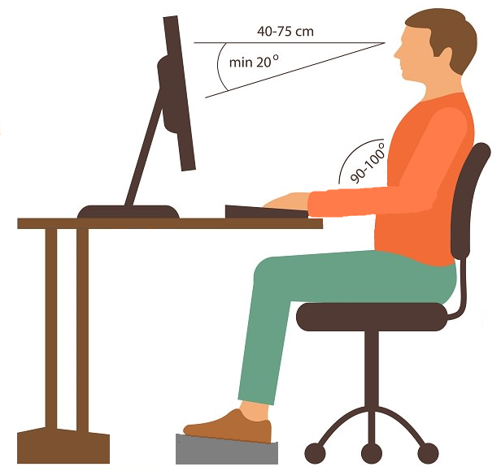
Elbows slightly above the desk top
2-3 finger distance between knees and seat
Footrest may be required to support feet
Adjustable back rest to support lumbar

TIPS:
- If you need to support your feet and don’t have a footrest, look around the house for objects that can act as a footrest for the short term.
- Don’t hold the mobile phone in your shoulder/neck. Use a pair of headphones or put the phone on speaker where appropriate.
- Don’t slouch on the couch or sofa with your laptop. Sit at a table or desk and check your seating position against the diagram above.
- Do you have a cushion that can increase your seat height if you need it?
- If you are feeling sore in the back, arms, neck or shoulder, don’t ignore it. Check your position and change your seating position.
- If you need help with your set up, talk with your Manager and contact your WHS Officer or HR Business Partner area.

PLEASE COMPLETE
Employee Name:
Date:
Once completed, please send the checklist to your direct reporting line for their review, and discuss any gaps that need to be addressed.
For more information

Visit:
- FACS intranet: My safety and wellbeing
- Justice intranet: Work, health and safety
- DCJ COVID-19 website: Information for DCJ staff - Working from home
- SafeWork NSW: Working from home during COVID-19

